Installing Ubuntu Linux
“Feisty Fawn” - Server Version 7.04

The Installer

If you do a default installation you will end up with a server that uses DHCP to obtain it's network address, a file system of the form:

/ (root) [All of disk minus 3xRAM]
<swap> 3xRAM

and a minimal installation of software.

Our Goal

We want you to install Ubuntu and set up the network manually entering in your fixed IP address, your correct host name and domain. In addition we will manually partition your file system. We will still create the same file system as you would get with an automated install, but in the real world you may need to understand how to create your own file system layout.

After the Initial Install

We will install the Ubuntu Desktop meta-package (Gnome 2.18 and Xorg) as well as properly configure this to work with your particular hardware by installing the xserver-xorg-video-intel package. Before we do this we'll do a number of other exercises as well.
Information you Need

The first PC in the classroom has the IP address 202.65.42.1 and the name pc1.conference.pacnog.org. The last PC has the IP address 202.65.42.31 and the name pc31.conference.pacnog.org. Please note that the name is lowercase and that no leading zero (0) is used in the name.

Your PC's Information

IP Address: 202.65.42.__
Netmask: 255.255.255.0 [or a “/24”]
Gateway: 202.65.42.254
DNS Server: 202.65.42.252
Hostname: ____.conference.pacnog.org

You will specify a user name and password of your choosing. One of the exercises will include creating a user named “admin” and a password we'll specify in class.

If you have questions during installation ask your instructor or an assistant.
Installing Ubuntu

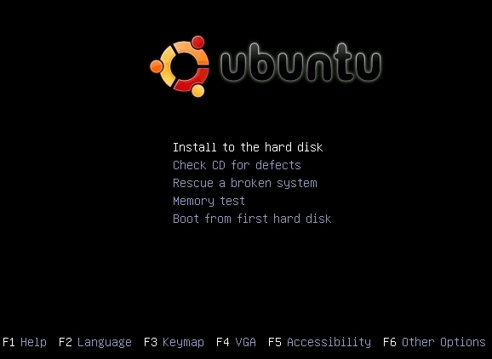
Step 1

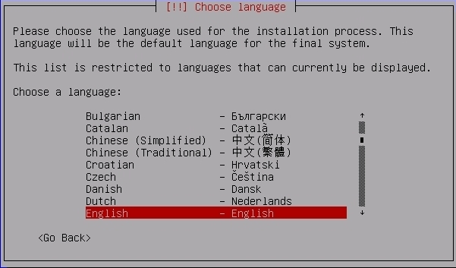
Step 2

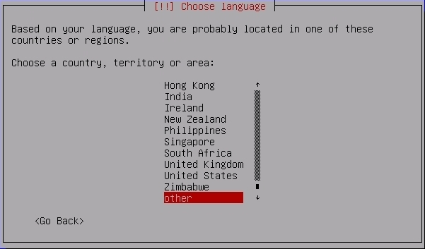

Step 3
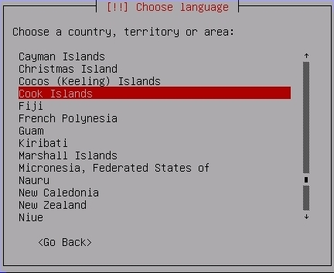
Step 4

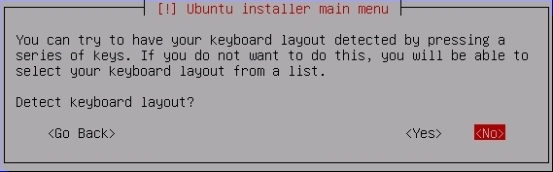

Step 5

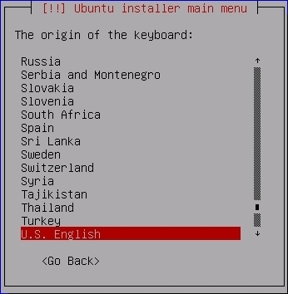

Step 6

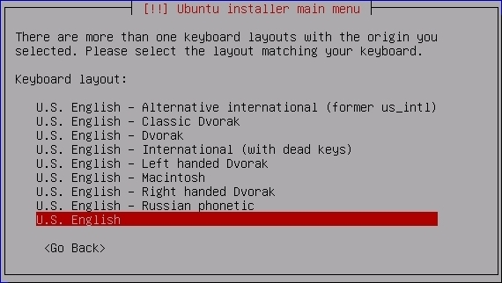
Step 7
If you can press “Cancel” in time please do so, otherwise see the screen in Step 8 and choose to “Go Back” to manually configure your network.

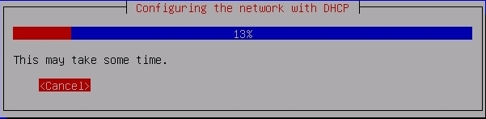

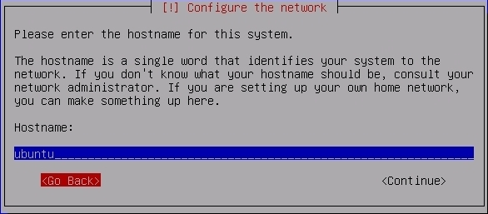
Step 8

Step 9
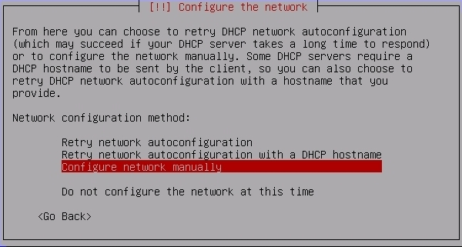

Step 10
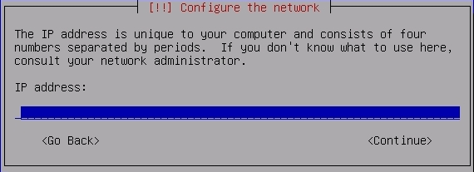
Step 11
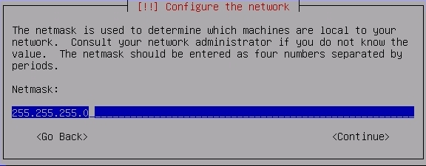
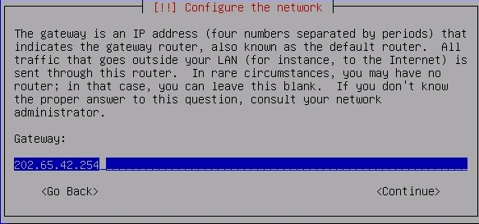
Step 12
Step 13

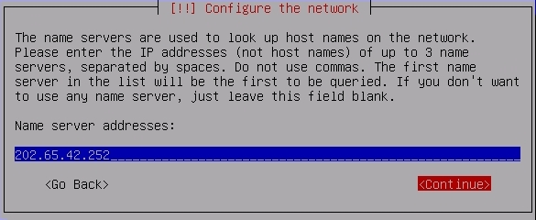
Step 14
The hostname is what you should have on your first page of this installation guide. And, remember to use lowercase characters.
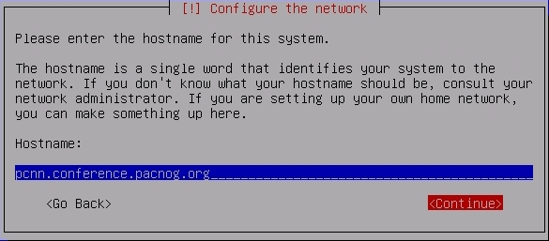

Step 15

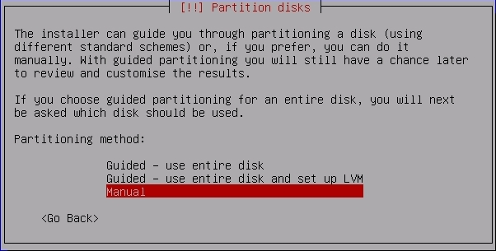
Step 16
Your machines likely already have partitions on them. If this is the case you need to delete each individual partition first, then you can create partitions. Here is a sample of deleting one partition. Repeat this until all partitions are deleted:
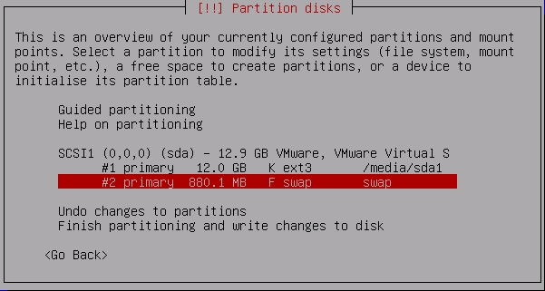
Step 17

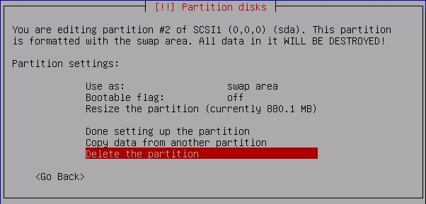
Step 18
Now repeat 16 through 18 until you have no partitions left. Then go on to step 19.
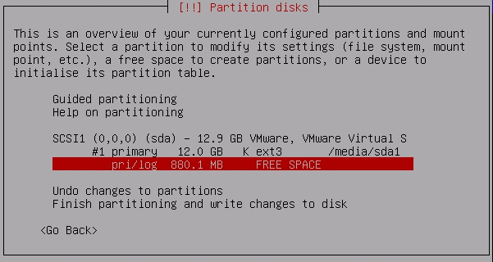

Step 19

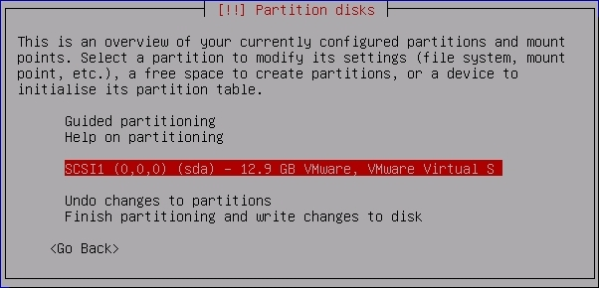
Step 20

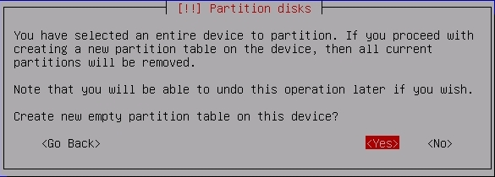

Step 21
Your partition size is likely to be different. Probably 40 GB.
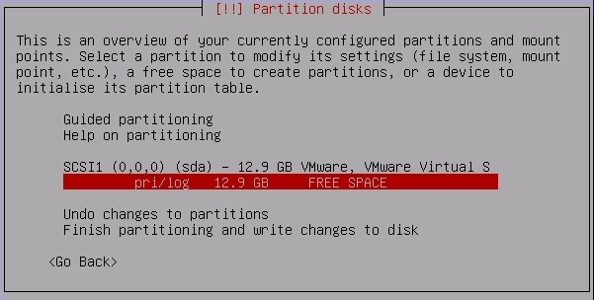
Step 22

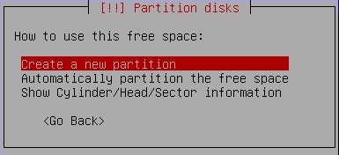

Step 23
Again, your disk size is different than what's in the dialogue on this screen. Choose a size that leaves 1.0 GB of space for SWAP. If you have a 40.0 GB drive, then enter “39.0 GB”, as shown below, is what you want to do.
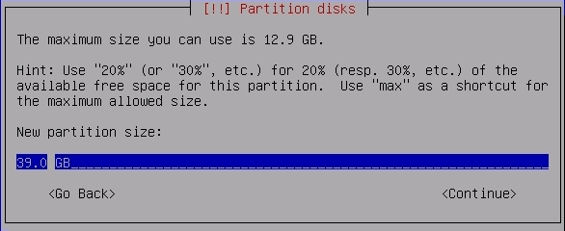
Step 24

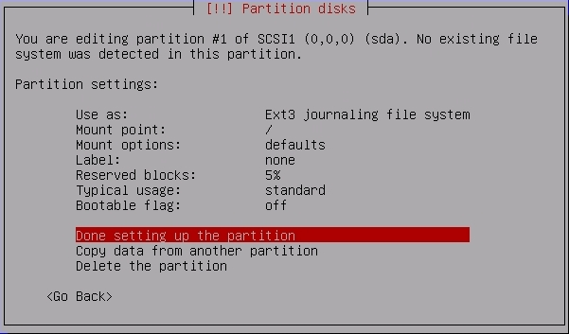
Step 25

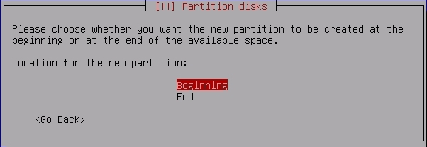
Step 26

Step 27

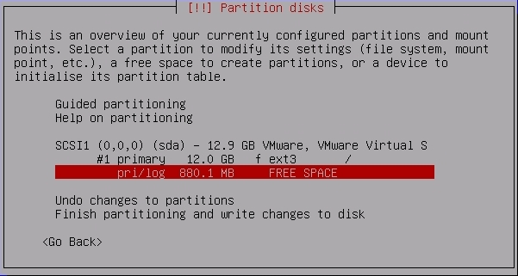
Step 28

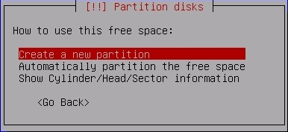

Step 29
If this dialogue is incorrect simply enter in the maximum size listed at the top of the dialogue for your machine. This will be the SWAP space (virtual memory) in use on your machine.
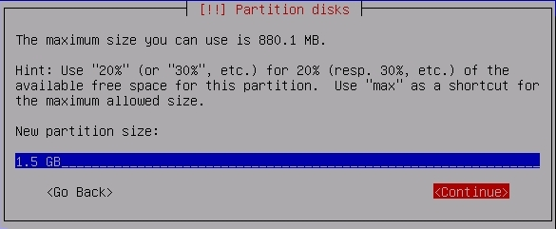
Step 30

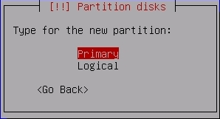

Step 31

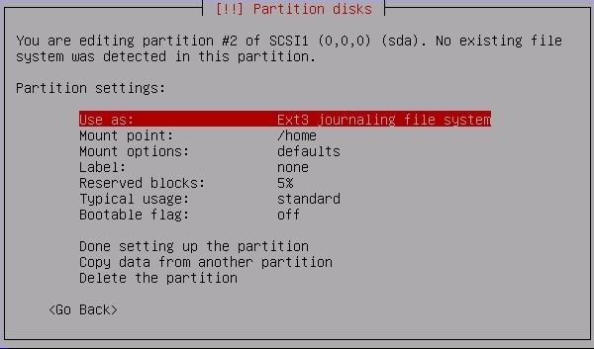
Step 32
Note the difference. You chose “Use as:” in step 31. This gives you the dialogue below. This is how you set this partition to be swap.
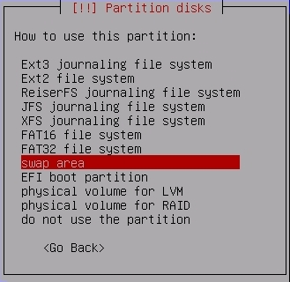

Step 33

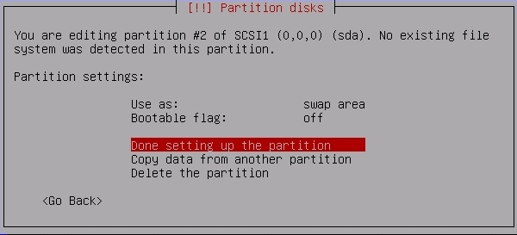
Step 34

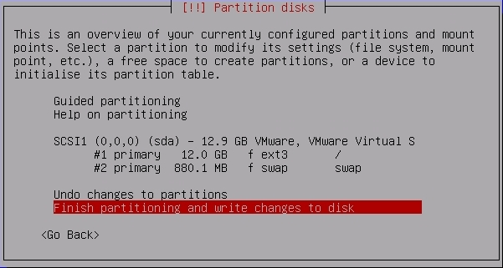

Step 35

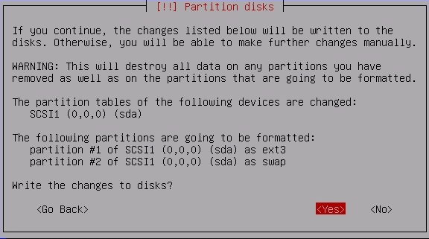
Step 36
You'll see this on the screen...
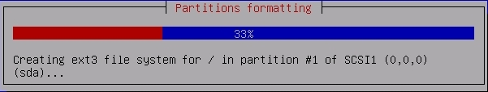
Step 37
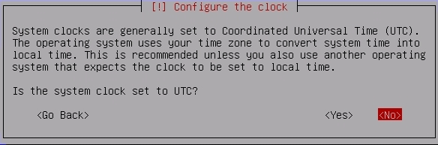
Step 38
You can enter in your real name here in place of “Jane User”.
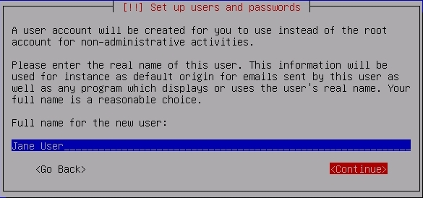
Step 39
If you wish a different username you can specify this here.
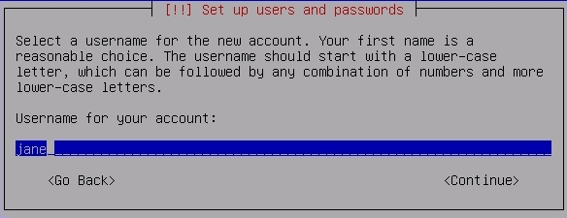
Step 40
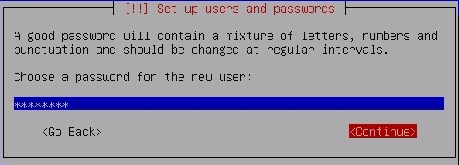
Step 41

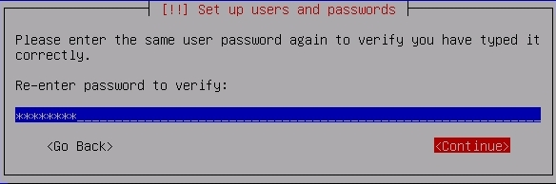
Step 42
Now you should see this on your screen...
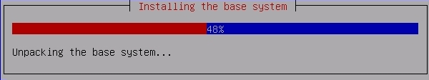
Step 43
And this...
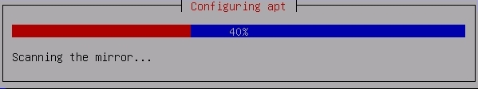

Step 44
For now please don't choose either of these...
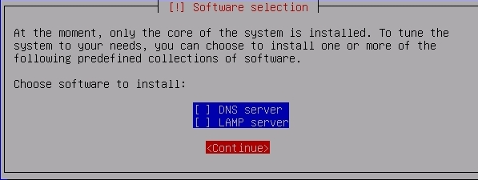
Step 45
You should see this. At 85% things will take a bit to finish...
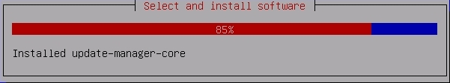
Step 46

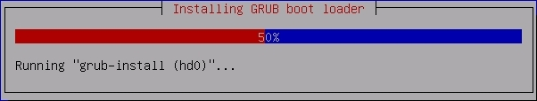

Step 47
Congratulations! You have installed Ubuntu.
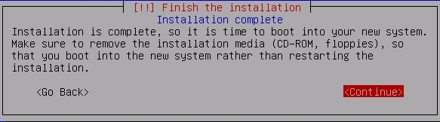
The Final Step

Your machine reboots and starts Ubuntu server. You will be presented with an initial log in prompt.

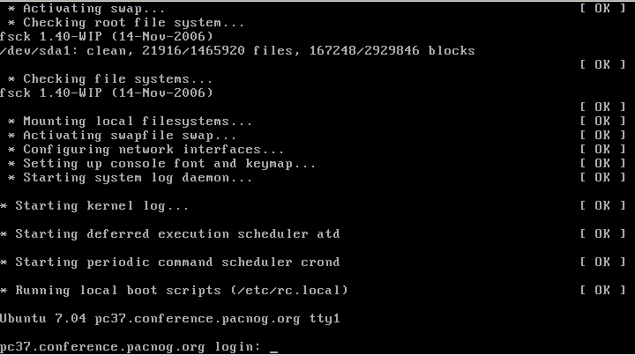
Next we'll be doing some exercises to practice some concepts in Ubuntu.

