Installing Ubuntu Linux
“Gutsy Gibbon” - Server Version 7.10

The Installer

If you do a default installation you will end up with a server that uses DHCP to obtain it's network address, a file system of the form:

/ (root) [All of disk minus 3xRAM]
<swap> 3xRAM

and a minimal installation of software.

Our Goal

We want you to install Ubuntu and set up the network manually entering in your fixed IP address, your correct host name and domain.

After the Initial Install

We will install the Ubuntu Desktop meta-package (Gnome 2.x and Xorg) as well as properly configure this to work with your particular hardware.

Information you Need

IP Address: ______________________________
Netmask: ______________________________
Gateway: ______________________________
DNS Server: ______________________________
Hostname: ______________________________
Keyboard Layout: ______________________________

You will specify a user name and password of your choosing. One of the post-install exercises will include creating a user named “admin” and a password that we will specify in class.
If you have questions during installation ask your instructor or an assistant for help.
Installing Ubuntu

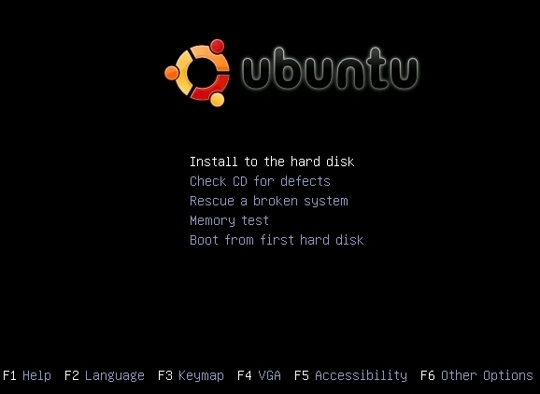
Step 1
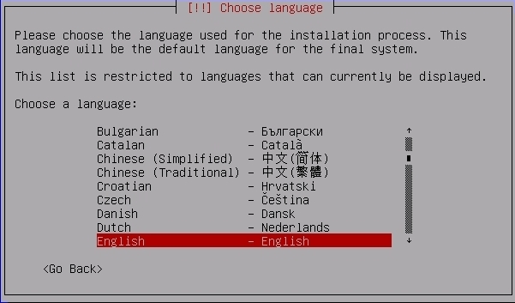
Step 2

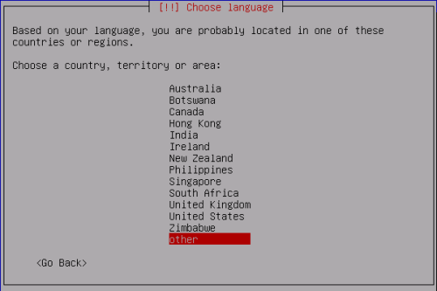
Step 3
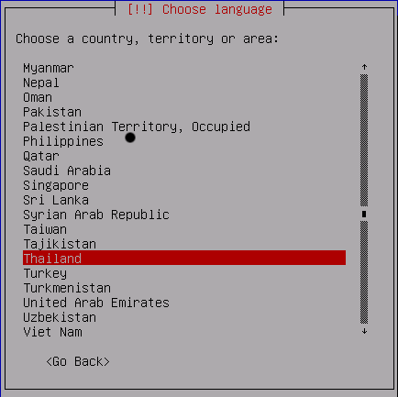
Step 4

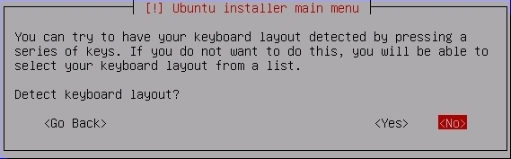

Step 5
This may be different depending on location.

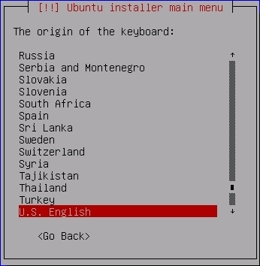

Step 6
Again, this may be different depending on location.

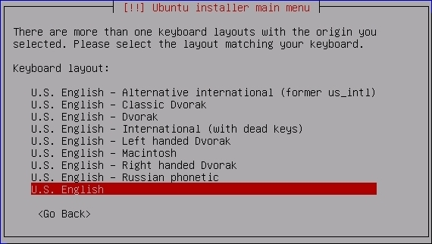
Step 7
You will see several screens appear as the installer loads various modules and detects hardware. Eventually you will see the screen below. If you can press “Cancel” in time please do so, otherwise see the screen in Step 8 and choose to “Go Back” to manually configure your network.

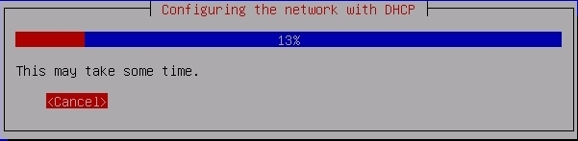
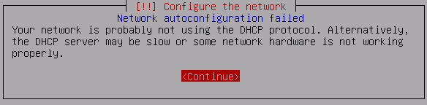
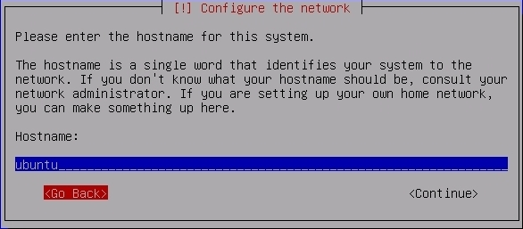
Step 8
Only if you did not press “Cancel” in step 7.

Step 9
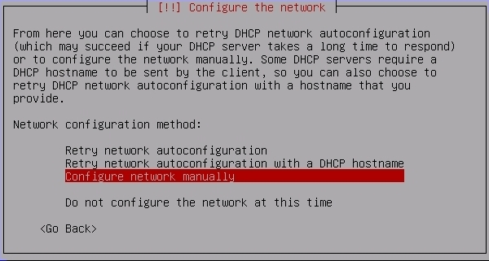

Note
On the next page for steps 10-14 you should use the values you filled in for your network information at the start of this exercise.
Step 10

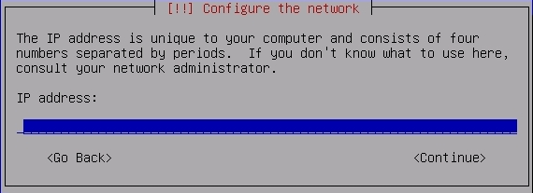
Step 11
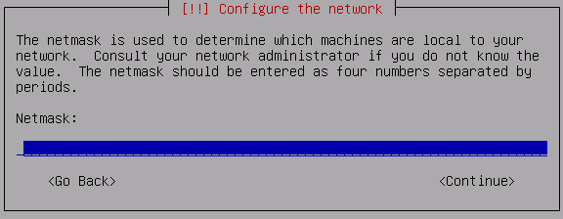
Step 12
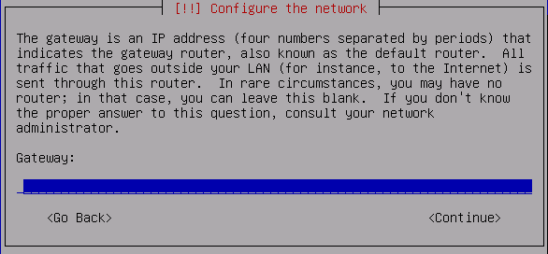
Step 13

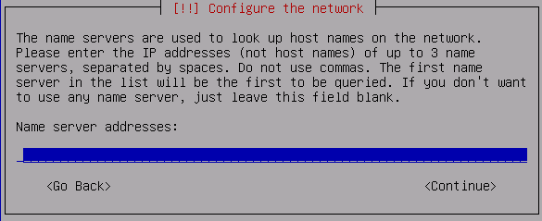
Step 14
Remember to use lowercase characters in your hostname.

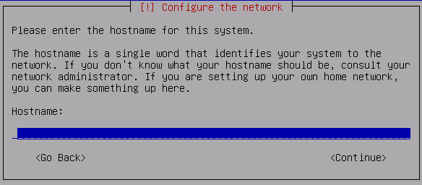

Partitioning
On the next page you will do a Guided partition of your drive.
Step 15

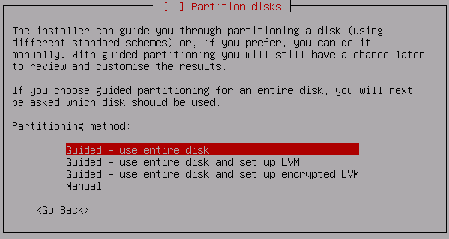
Step 16
The drive and size will be different for your machine.

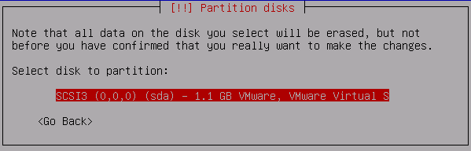
After this you should see some screens appear as the installer prepares to partition your drive. If you are asked to delete what is already on your machine you should do this.

Step 17
Be sure you choose “Yes” below.

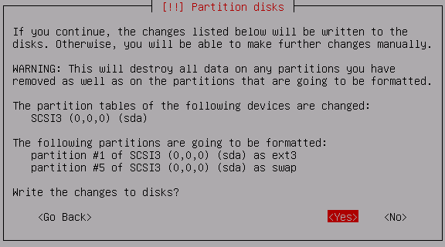
Again, you will see some screens appear as the installer completes partitioning your drive. Then you should see:

Step 18

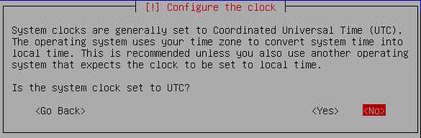
In reality you would probably want your server's clock to be set to Universal Time (UTC), but for purposes of our lab it is simplest if we choose “No” at this point.

Step 19
(Enter in a user name you wish to use in place of “Jane User”)

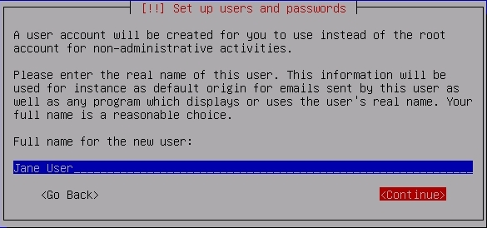
Step 20
(If you wish a different username you can specify this here.)

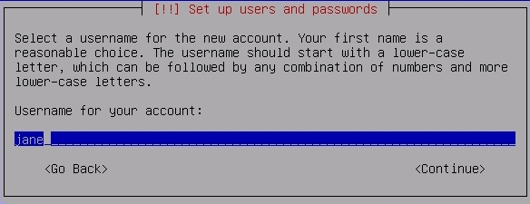

Step 21

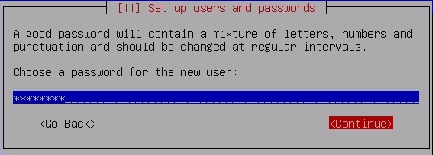
Step 22

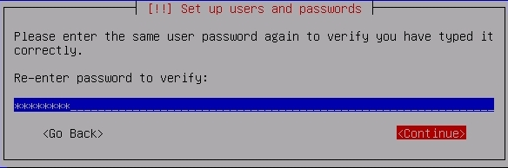
Step 23
Now you should see this on your screen for a fairly long time...

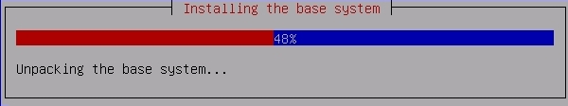

Step 24
And then this...

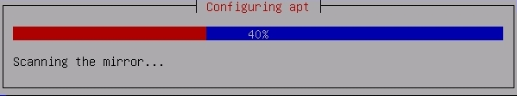
Step 24a
You should not see this screen.

If you see this, then your network settings are likely broken. At this point installation will take a very long time. Let your instructor or assistant know that you are seeing this screen as restarting the installation is probably faster than waiting for completion.

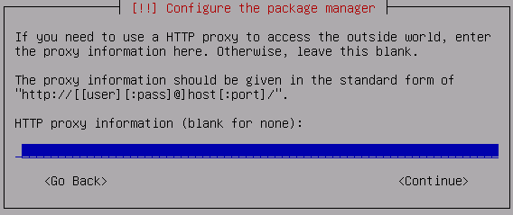

Step 25
For now please don't choose to install any packages.

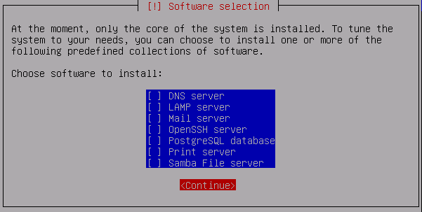

Step 26
You should see this. At 85% things will take a bit to finish..
.
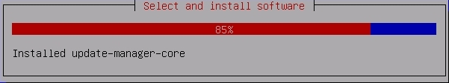
Step 27

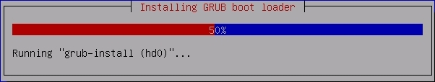

Step 28
Congratulations! You have installed Ubuntu.

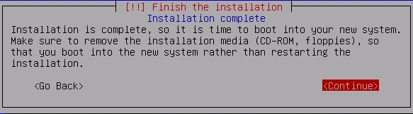
The Final Step

Your machine reboots and starts Ubuntu server. You will be presented with an initial log in prompt. If your screen stops at “Running local boot scripts (/etc/rc.local)” just press ENTER to get the initial log in prompt.

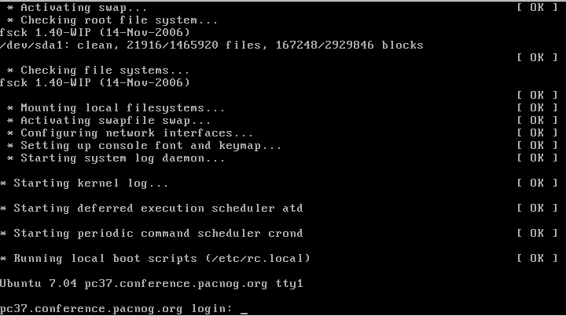
Next we'll be doing some exercises to practice some concepts in Ubuntu as well as setting up your Ubuntu environment to run with a graphical user interface (GUI) using the Xorg XWindow system with the Gnome desktop.
Manual Partitioning of Drives

During this installation we did a Guided Partition of your entire drive. Manually partitioning your drive using the Ubuntu installer involves numerous steps. You may wish to do this if you install Ubuntu back at your own location this workshop includes an appendix to this installation guide that gives you step-by-step instructions for doing a sample manual partition of a drive during installation of Ubuntu.

The appendix on the following pages has step-by-step instructions for doing this.

If you are looking at a printout without an appendix, the appendix is available in the on-line version of this document on your workshop's web site. The document is linked in the Detailed Agenda for this workshop.
Appendix

Manual Partitioning of Drives

In Step 15 of the installation we chose “Guided – use entire disk”. If you wish to manually partition a drive for installation of Ubuntu you should follow these steps instead.

Step 1

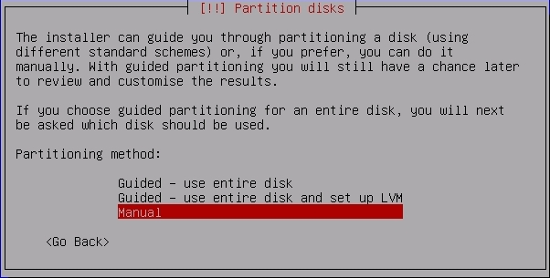

Step 2
Your machine may already have partitions on it. If this is the case you need to delete each individual partition first, then you can create partitions. Here is a sample of deleting one partition. Repeat this until all partitions are deleted:

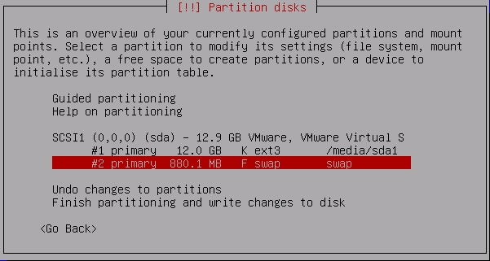
Step 3

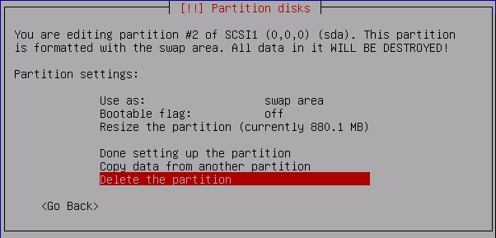

Step 4
Now repeat 1 through 3 until you have no partitions left. Then go on to step 5.
Step 5
These screens show a sample drive. Your drive will be different.

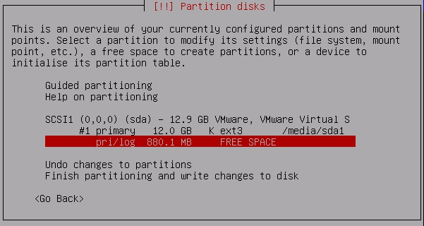

Step 6

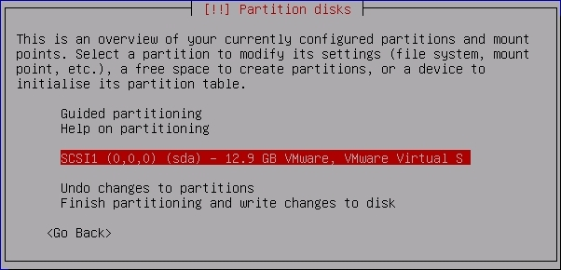
Step 7

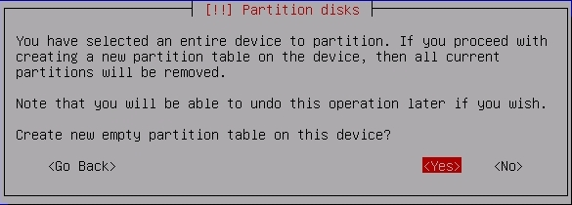
Step 8
Your partition size will be different.

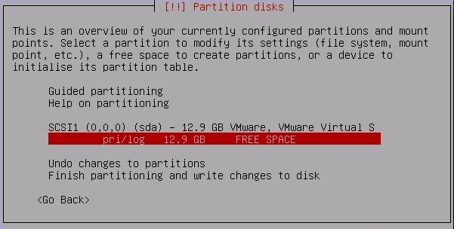

Step 9

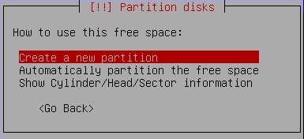

Step 10
Again, your disk size is different than what's in the dialog on this screen. If, for example, you had 1GB of RAM you might want 1 or 2GB for swap. If you are using 40GB of disk space, then to have 1GB of swap space you would do the following:
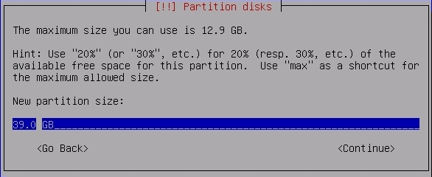

Step 11

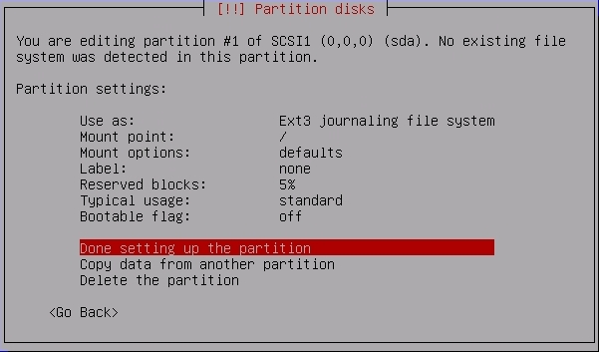

Step 12

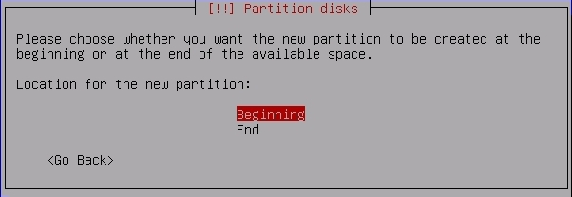

Step 13

Step 14

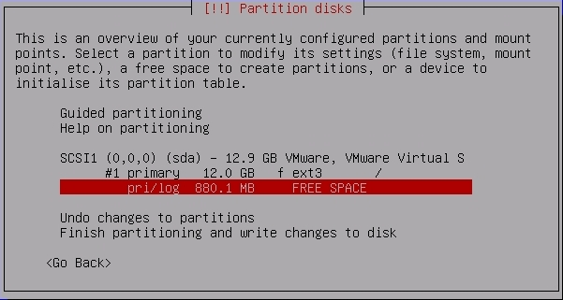

Step 15

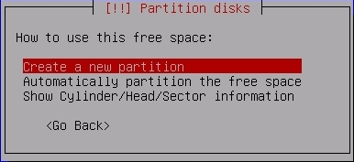

Step 16
If this dialog is incorrect simply enter in the maximum size listed at the top of the dialog for your machine. This will be the SWAP space (virtual memory) in use on your machine.

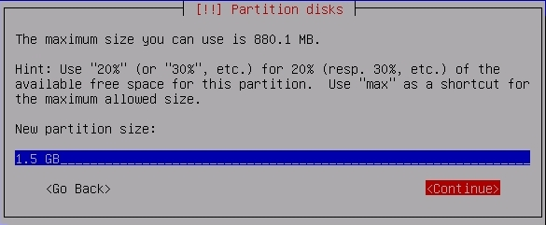
Step 17

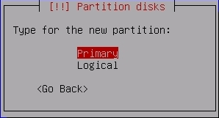

Step 18

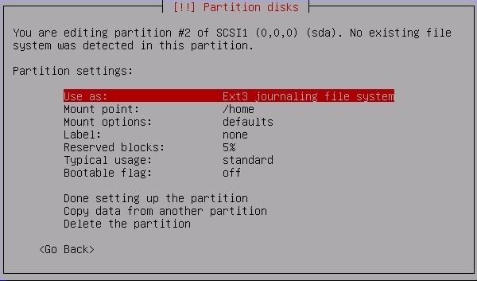
Step 19
Note the difference. You chose “Use as:” in step 18. This gives you the dialog below. This is how you set this partition to be swap.

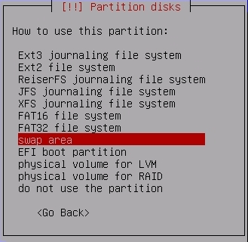

Step 20

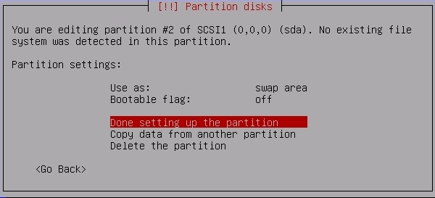
Step 21

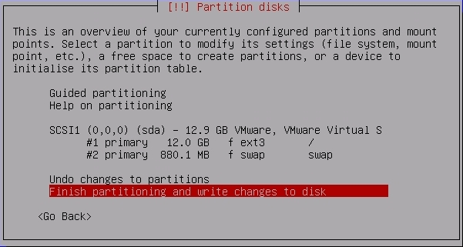

Step 22

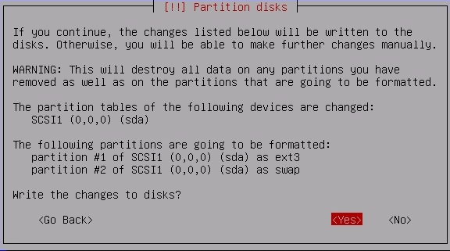
Step 23
You'll see this on the screen...

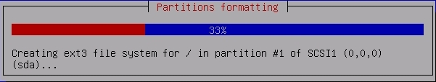
Once this dialog finishes you are done partitioning your drive. Note that the partition we created was the same as you get if you choose “Guided – us entire disk” in Step 1. Naturally you could choose to partition your drive any way you wish.

