Network Management & Monitoring
Request Tracker (RT) Installation and Configuration

Notes:
- Commands preceded with "$" imply that you should execute the command as a general user - not as root.
- Commands preceded with "#" imply that you should be working as the root user.
- Commands with more specific command lines (e.g. "RTR-GW>" or "mysql>") imply that you are executing commands on remote equipment, or within another program.
- If a command line ends with “\” this indicates that the command continues on the next line and you should treat this as a single line.

Exercises

Exercise 0

Log in to your PC or open a terminal window as the sysadm user.

Exercise 1

Install the necessary packages for RT.

$ sudo apt-get install mysql-server-5.1
$ sudo apt-get install rt3.8-apache2
$ sudo apt-get install rt3.8-clients
$ sudo apt-get install rt3.8-db-mysql
$ sudo apt-get install request-tracker3.8
$ sudo apt-get install mutt

A quicker way to do this is to specify all the packages on a single line. (Hint, you can copy and paste this if you wish):

$ sudo apt-get install mysql-server-5.1 rt3.8-apache2 \
rt3.8-clients rt3.8-db-mysql request-tracker3.8 mutt

Respond “Yes” when prompted if you wish to install the packages.

You will now be presented with several windows. Read the instructions below each item to see how to respond:

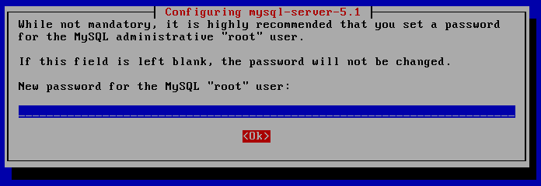

If you enter nothing, then you will receive this prompt again. Please use the administrative password you have been given in class for your machine. If you do not know what this is, then ask your instructor.

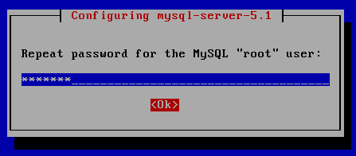

Enter the same password again.

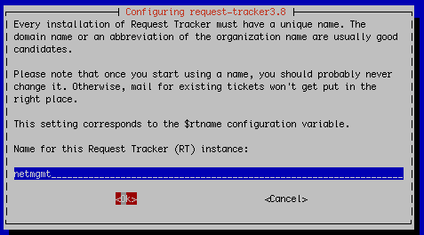

Use the name “netmgmt” for this instance of RT. (Do not use your machine name)

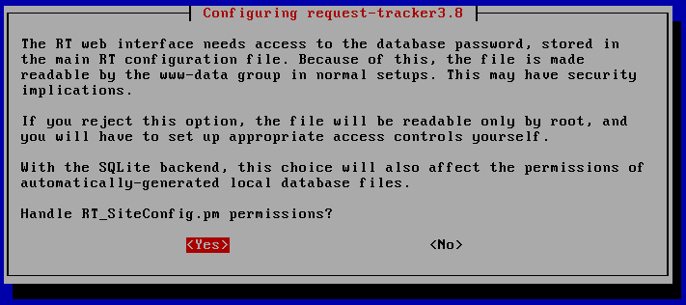

Choose “Yes” – Be aware of this issue. You may wish to manually go and change the permissions for the RT configuration file at a later time.

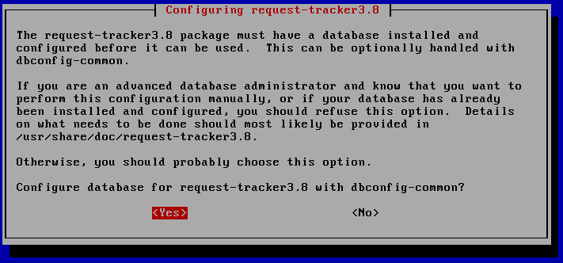

Choose “Yes”

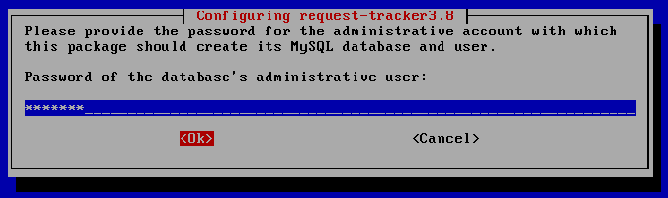

To keep our installation simple, please use the same password as you did for the MySQL “root” user. You will be prompted either one or two times more for the same password. Please enter it again and select “<OK>” to continue.

At this point you have installed Request Tracker version 3.8. In order to access RT via the Apache web server you need to make one small change.

$ cd /etc/apache2/conf.d
$ sudo ln -s /etc/request-tracker3.8/apache2-speedycgi.conf .
$ sudo /etc/init.d/apache2 reload

RT is now running and available on your machine.

Exercise 2

RT Configuration: root User Password Change

Open a web browser and point it to the IP address of the machine where you installed RT.

For example open the link:

http://pcN.ws.nsrc.org/rt/

You will now see the opening RT screen. You should log in using the default username and password for a new installation. These are “root” and “password” -

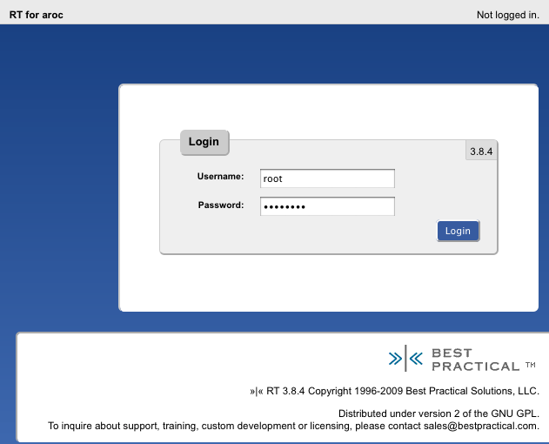

One you have logged in let’s update the password for the root RT user. To do this click on Configuration in the left menu, then click on the Users entry.

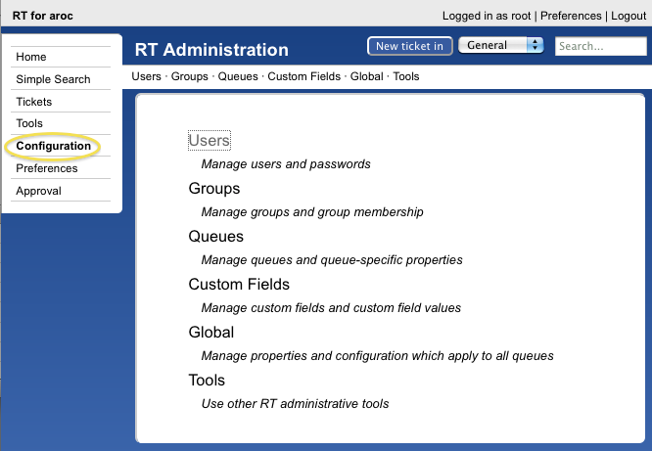

Once you’ve clicked on Users you should see a screen like the one below:

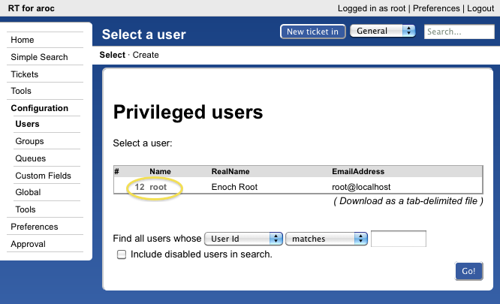

Click on the root entry and you will now see a detail screen for this user:

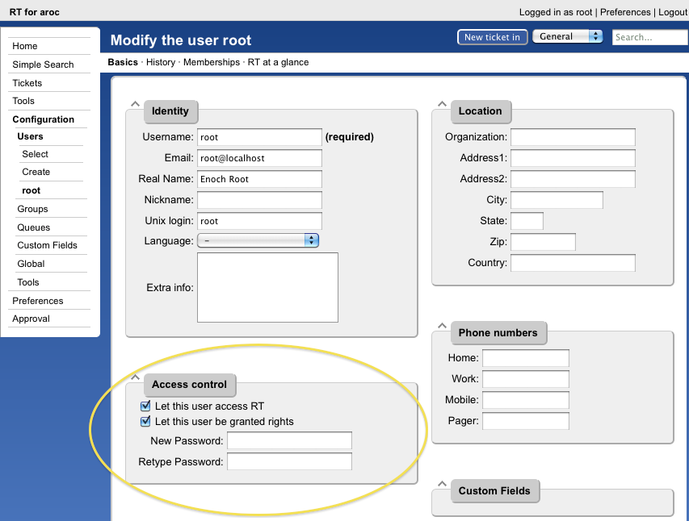

Change the password for the root user to the administrative password that you are using in class. Once you have done this press the Save Changes button at the bottom of the screen (not visible in our screen capture). You’ll see this at the top of the page if all goes well:

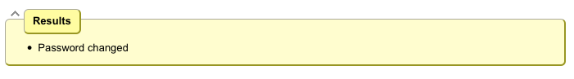

Exercise 3

RT Configuration: Create a User

You should already be logged in to RT as the “root” user. If not, log back in as root.
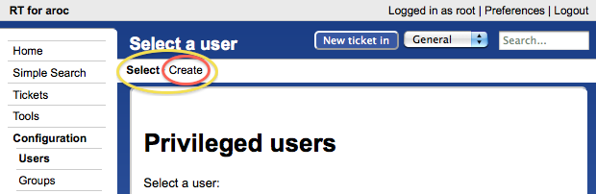

On the left of the screen click Configuration ➔ Users and then click on the Create item in the upper-left of the screen.
You will now be presented with the following dialogue. Fill in the fields, and make sure the checkbox "Let this user be granted rights" is checked.

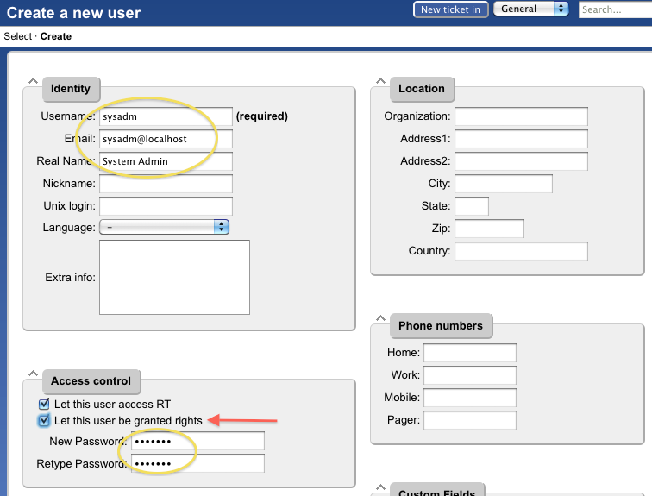

Use the same password for “sysadmin” as you are using in class. Be sure you check “Let this user be granted rights”. Once done, scroll down the page and click on the Create button (bottom right). You should see this:

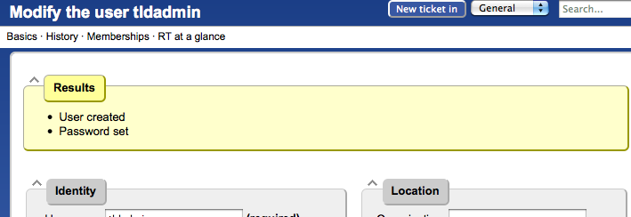

Exercise 4

RT Configuration: Create a Group

- Click on Configuration (left menu), then Groups (middle of screen).
- Click on Create (top menu)

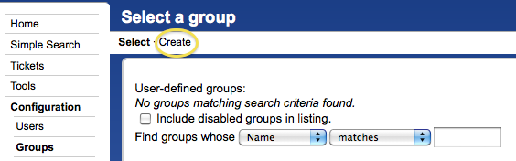

- Fill in the name: "netmgmt", and add a description, then click on "Create"

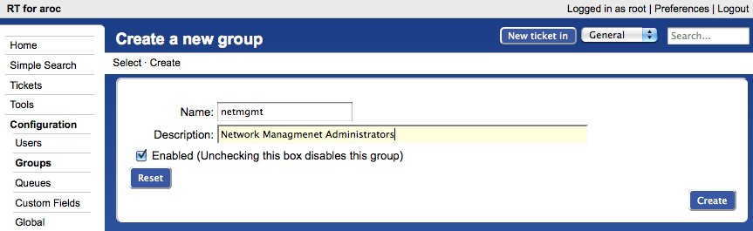

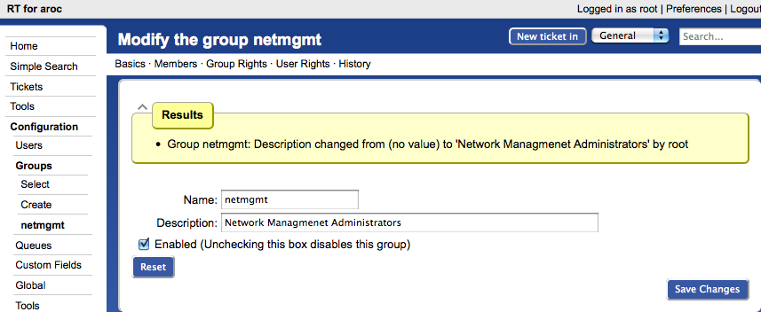

Exercise 5

RT Configuration: Add Members to a Group

- Click on Configuration (left menu), then Groups (center menu)
- Click on "netmgmt" (the group you just created)
- Click on Members (top menu)

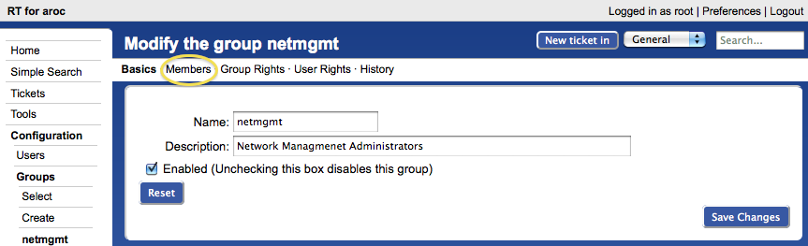

- In the "Add members" list (right), select the user you created in step 3. This is the “sysadm” user, with the description “System Admin.”:

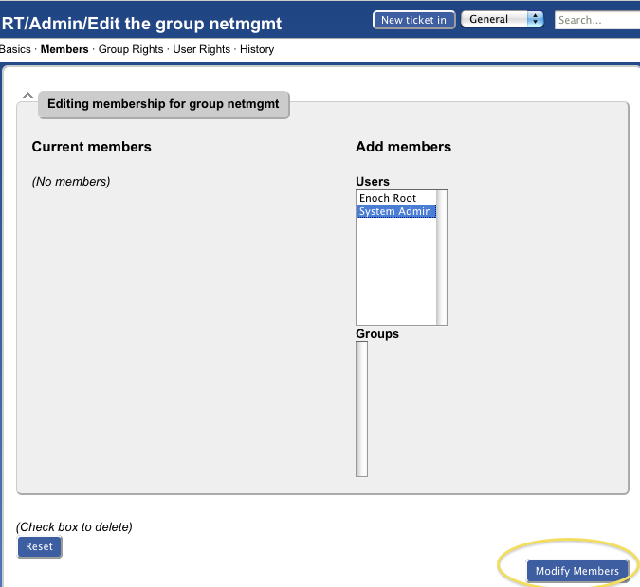

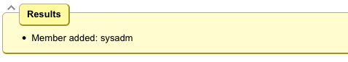

Exercise 6

RT Configuration: Create a New Queue

- Click on Configuration (left menu), then Queues (center menu)
- Click on Create (top menu)

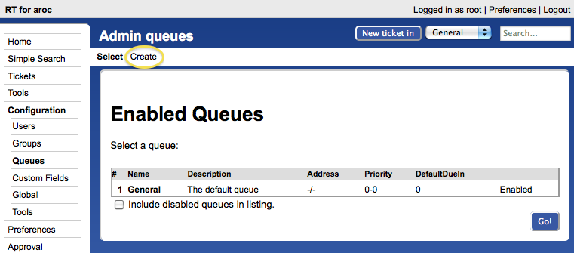

- Fill in the fields. Let’s use the following values:
Queue Name: net
Description: Network Problems
Subject Tag: Request Tracker: NET
Reply Address: net@localhost
Comment Address: net-comment@localhost

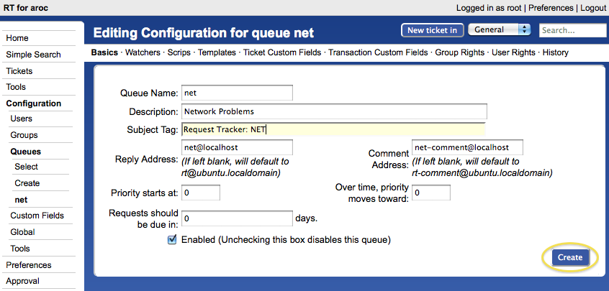

- Click on Create:
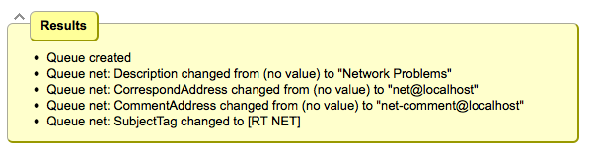
If your Request Tracker box has a fully qualified domain name you can use this instead of “localhost”.

Exercise 7

RT Configuration: Give Rights to our Group on the Queue

- Click on Configuration (left menu), then Queues (center menu).
- Click on "net" (the queue that you just created).
- Click on "Group Rights" (top menu).

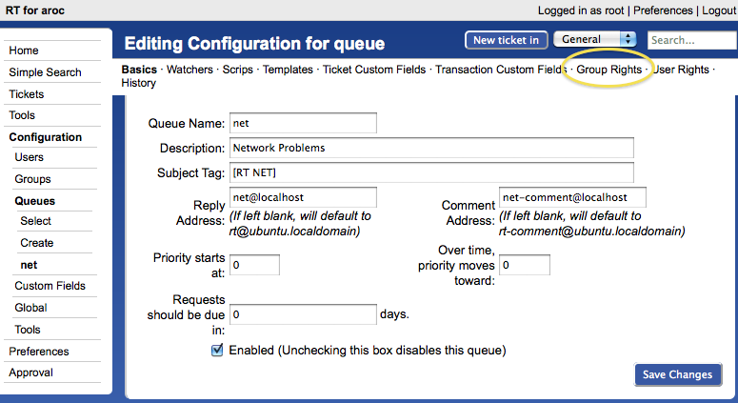

The following menu is pretty long and complex. Here is what you should do:

In the "Everyone" Group, on the right side under New Rights select these three items. Use the CTRL key (or Apple key on a Macintosh) to select multiple items:

- CreateTicket
- ReplyToTicket
- SeeQueue

In the netmgmt Group select everything except for the choice “no value” – You can use the shift key to do this. Once this is done, press the Modify Groups Rights button on the bottom right of the page.

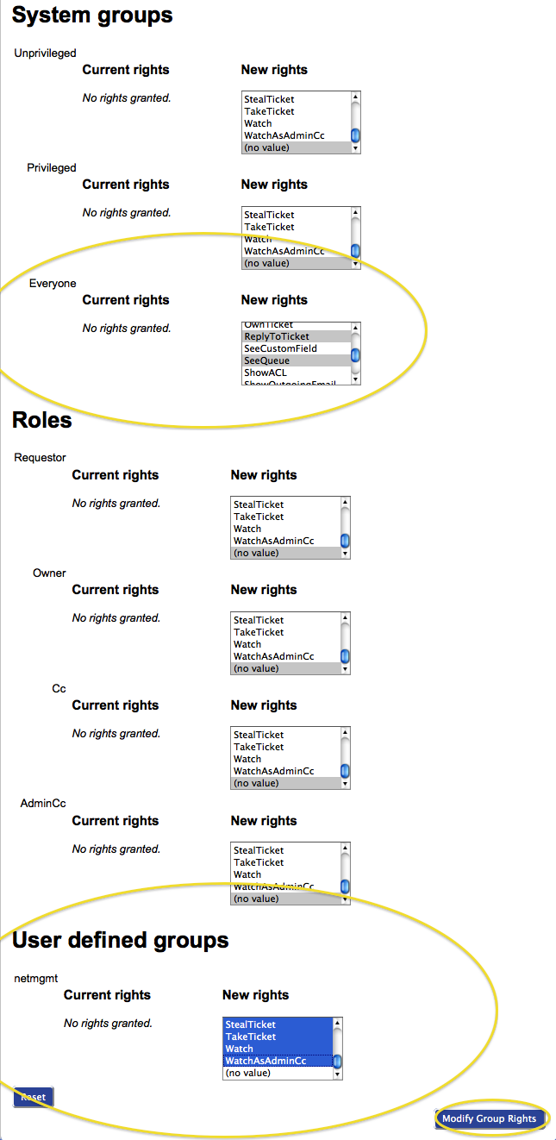
You will see a bunch of this:

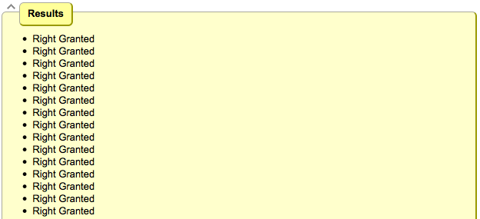

and all the rights that the Group “netmgmt” now has on the NET queue (bottom of page):
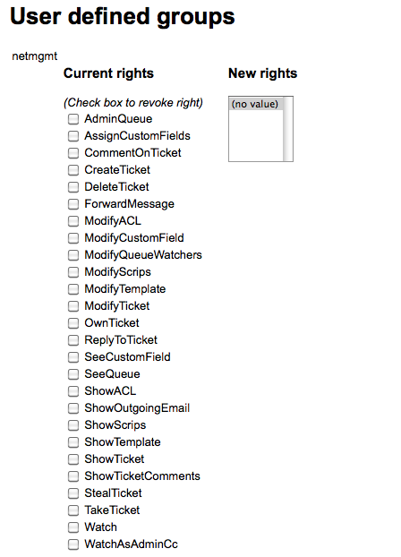

Exercise 8

RT Configuration: Log in as sysadmin

Log out of RT and log back in as the sysadmin user you have created.

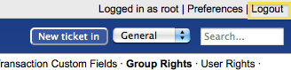

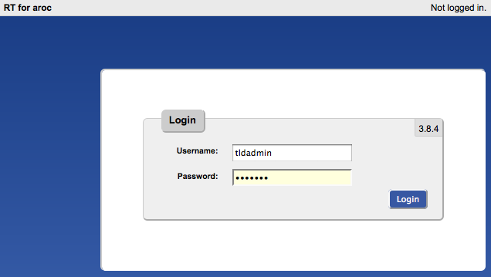
sysadm

You should see this:

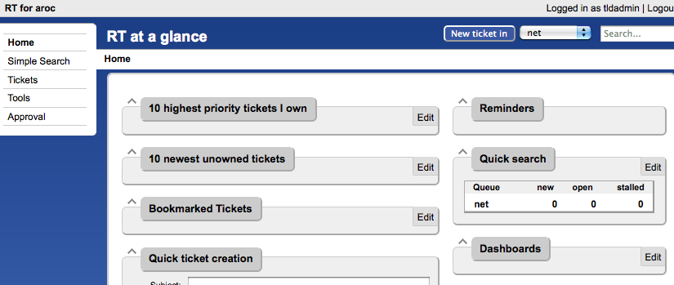
sysadmin
At this point RT has been properly configured for initial operation. Now we must configure email properly to talk with our new “net” queue in RT.

Exercise 9

RT Configuration: Email

RT will work with the MTA (Mail Transfer Agent) of your choice. In our case we are using Postfix configured to run as an MTA for an “Internet Site” – that is, to deliver email locally and remotely using SMTP.

Edit the file /etc/aliases

Add the following two lines at the end of the file:

net-comment: "|/usr/bin/rt-mailgate --queue net --action comment --url http://localhost/rt/"
net: "|/usr/bin/rt-mailgate --queue net --action correspond --url http://localhost/rt/"

Save the file and exit, then run the command:

$ sudo newaliases

Exercise 10

RT Configuration: Create an Email and Tickets

Let’s create an email and send it to the RT “net” queue. Do this as the sysadm user (not as root!):

$ echo "Problem with my router" | mail -s "Router problem" net@localhost

Now check that you have received email:

$ mutt –f /var/mail/sysadm

You should see an email from Request Tracker acknowledging that your ticket has been created. If you do not take these steps, and then send the mail again:

$ sudo touch /var/mail/sysadm
$ sudo chown sysadm:mail /var/mail/sysadm

Exercise 11

RT Configuration: View, Reply, Resolve, Reopen Tickets in Request Tracker

Go back to your web browser where you are logged in to RT as the sysadmin user and click on the ticket in the main view page (what you see when you first log in):
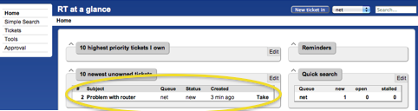

You will see a bunch of information about the ticket. Scroll to the bottom of the page. Here you can Reply to the ticket:

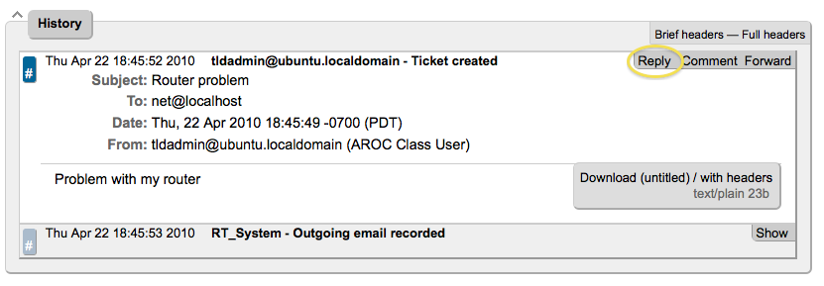

Go ahead and type in a reply, set the Status of the ticket to Resolved (upper-right drop-down menu), and then click on Update Ticket (bottom-right):

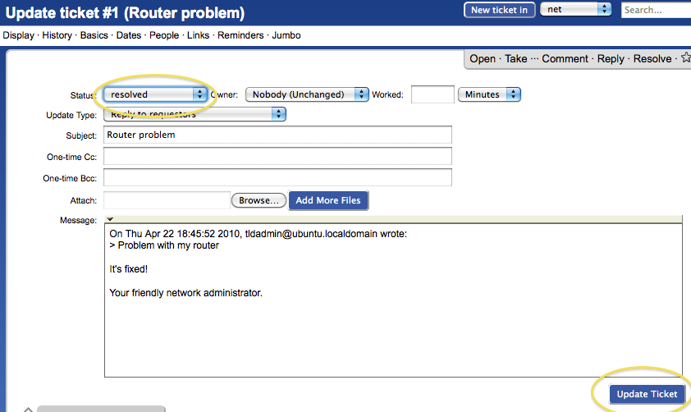

You should see this

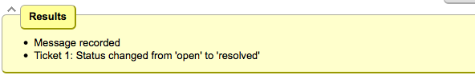
The ticket is currently “Resolved,” but you can either reopen the ticket via the RT web interface at any time, or if the original ticket creator (sysadmin in this case) replies to the email you just sent, then the ticket will be reopened.

View the history at the bottom of the page to see that the ticket is currently closed:
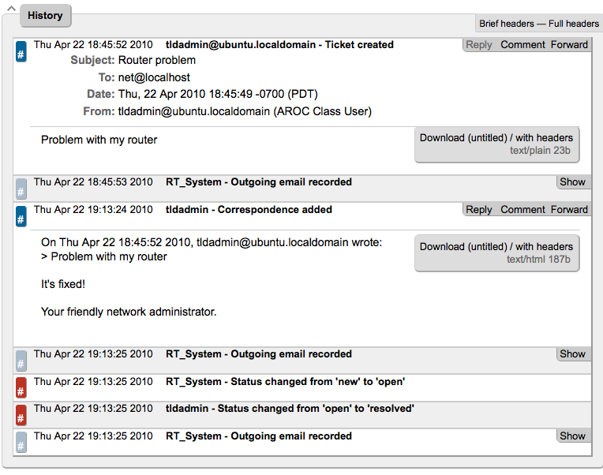

If you went back to your terminal session as the sysadmin user and typed:

$ mutt –f /var/mail/sysadm

and responded to the email generated from Request Tracker, then your ticket status will change. You can see this by reloading the RT web page for the ticket and viewing the history at the bottom of the page:

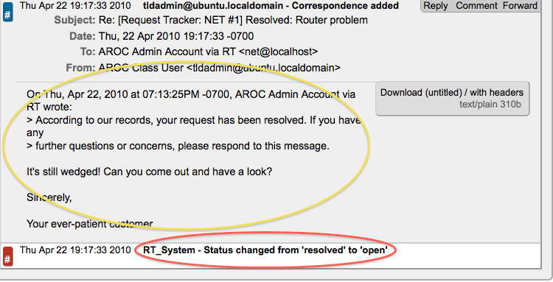

You now have a functioning RT instance with email integration. A bit later we will extend the use of RT by integrating it with other Network Monitoring software using the rt-mailgate facility that we have already configured in the /etc/aliases file.

Exercise 12

Finding a ticket once it’s closed.

After a ticket has been resolved or closed may notice that it disappears from your Queue. Actually finding a closed ticket requires a few steps. First, click on Tickets and you will see a screen like this:

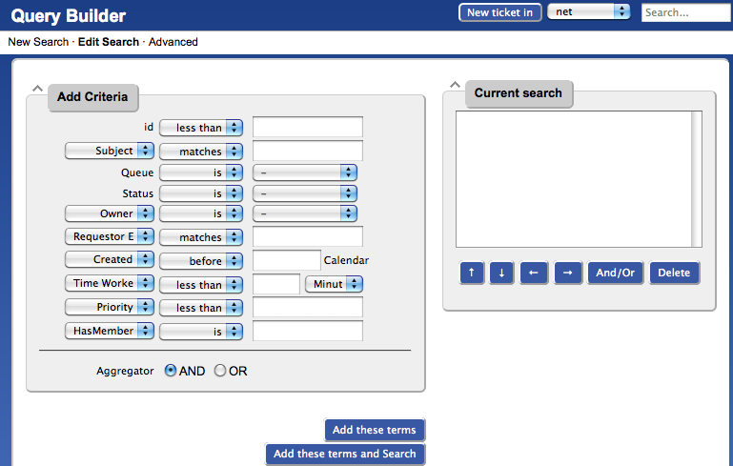

If you are going to search for items in a queue and there are already items in the “Current search” box, then you should delete the items from the “Current search” box first. Next in the “Add Criteria” box in the “Queue” choice select the “net” queue from the drop-down menu (see below):

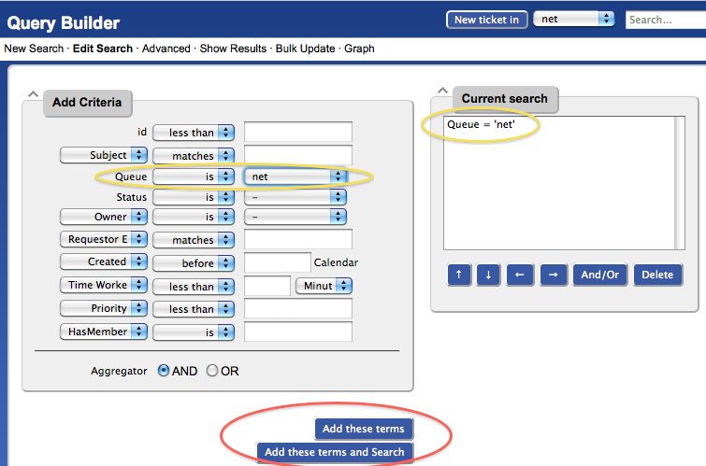

Click on “Add these terms” or “Add these terms and Search” – If you just do “Add these terms” then go to the bottom of the page and click on “Update format and Search” – RT will keep the search terms until you delete them at a later time.

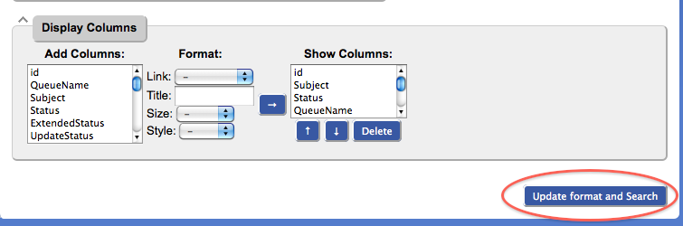

And the results of your search will look something like this and you will be able to view tickets that have been closed, resolved, etc.:
