Layer 2 Network Design Lab

Introduction

The purpose of these exercises is to build intra-building Layer 2 networks utilizing the concepts explained in today's design presentations. The exercises are focused on the 2nd layer of the OSI model, that is, switching. Students will see how star topology, aggregation, Virtual LANs, Spanning Tree Protocol, Port bundling and some switch security features are put to work.

The lab exercises will include:
    - Basic switch configuration
    - Spanning Tree configuration
    - Redundant configuration
    - Control Plane Protection configuration
    - Port Bundling
    - MST Configuration
    - DHCP Snooping

There will be 5 groups of 4-6 students, with 4 switches per group. The distribution of IP address space for the building (Layer 2) networks will be as follows:
- Group 1: 10.10.64.0/24
- Group 2: 10.20.64.0/24
- Group 3: 10.30.64.0/24
- Group 4: 10.40.64.0/24
- Group 5: 10.50.64.0/24

Possible switch types used in the LAB
Modular Switches
- Hewlett Packard Procurve Switch 4000 (J4121A)
- Hewlett Packard Procurve Switch 4104gl (J4887A)
Standalone Switches
- Hewlett Packard Procurve Switch 2824 (J4903A)

Brief introduction to switch configuration
See Appendix A

Network Diagram
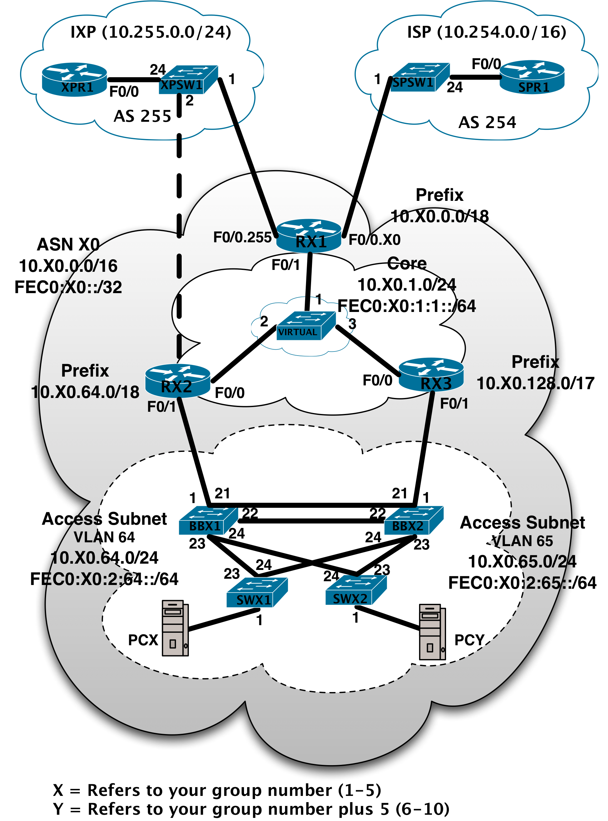
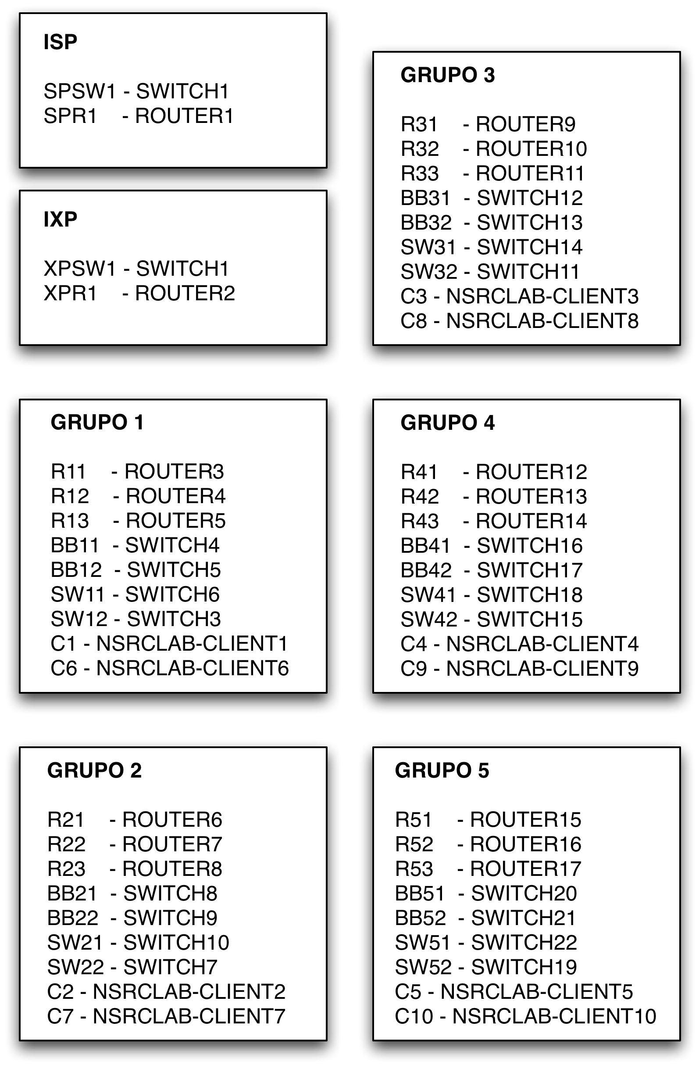

Connecting to the NSRC Remote Lab (If needed)

Access to all remote devices will via Secure Shell. Use the topology diagram and the device/console name reference to identify your devices.

Access to network devices from an SSH CLI:
ssh nsrc:switch4@nsrclab-console1-gw.uoregon.edu
ssh nsrc:router3@nsrclab-console1-gw.uoregon.edu

If Using Putty:
1. In the `Host Name' box, enter nsrclab-console1-gw.uoregon.edu
2. In `Connection type', select "SSH"
3. Press the `Open' button, and type the username as:
nsrc:switch1
nsrc:router3
etc.

Access to the Linux workstations via an SSH CLI:
ssh nsrc@nsrclab-client1.uoregon.edu
If Using Putty:
1. In the `Host Name' box, enter nsrclab-client1.uoregon.edu
2. In `Connection type', select "SSH"
3. Press the `Open' button, and type the username as:
nsrc

Your instructor will provide the passwords.

Spanning Tree Design Information

Priority Matrix
Multiplier | Priority Value | Description | Notes
0 | 0 | Core Node | The core switches/routers will not be participating in STP...defined in case they ever are
1 | 4096 | Redundant Core Nodes | The core switches/routers will not be participating in STP...defined in case they ever are
2 | 8192 |  | Reserved
3 | 12288 | Building Backbone
4 | 16384 | Redundant Building Backbones
5 | 20480 | Secondary Backbone | This is for building complexes, where there are separate building (secondary) backbones that terminate at the complex backbone.
6 | 24576 | Access Switches | This is the normal edge-device priority.
7 | 28672 | Access Switches | Used for access switches that are daisy-chained from another access switch. We're using this terminology instead of "aggregation switch" because it's hard to define when a switch stops being an access switch and becomes an aggregation switch.
8 | 32768 | Default | No centrally managed network devices should have this priority.

Cisco / HP STP Protocol Version Compatibility Table

Cisco 6509 Mode | Switch Type | Switch Protocol | Switch Force Protocol (HP only) | Does it work?
Mst | HP 2824 | stp | stp | yes
Mst | HP 2824 | rstp | stp | yes
Mst | HP 2824 | rstp | rstp | yes
Mst | HP 2824 | mst | mst | yes
Mst | HP 4000M | stp | N/A | yes
Mst | C 3560 | any | N/A | yes
Mst | HP 4104gl | stp | stp | yes
Mst | HP 4104gl | rstp | stp | yes
Mst | HP 4104gl | rstp | rstp | yes
Mst | HP 2810 | mst | stp | yes
Mst | HP 2810 | mst | rstp | yes
Mst | HP 2810 | mst | mst | yes
Mst | HP 2524 | stp | stp | yes
Mst | HP 2524 | rstp | stp | yes
Mst | HP 2524 | rstp | rstp | yes
Mst | HP 2524 | rstp | rstp | yes
Mst | HP 2524 | rstp | rstp | yes
pvst+ | Non Cisco - Non-trunking | any | any | no
rapid-pvst+ | Non Cisco - Non-trunking | any | any | no

Compatibility Matrix
 | c6500 | c3750 | c3560 | c2960 | hp1600m | hp224 | hp2400m/2424m | hp2512/2524 | hp2600-8/2626/2650 | hp2810
Switch Feature
STP | pvst+ | pvst+ | pvst+ | pvst+ | x | x | x | x | x | x
RSTP | rapid-pvst | rapid-pvst+ | rapid-pvst+ | Rapid-pvst+ |  |  |  | x | x | x
MST | x | x | x | x |  |  |  |  | x | x
Root Guard | x | x | x | x |  |  |  |  | x | x
BPDU Filter | x | x | x | x |  |  |  |  | x | x
BPDU Guard | x | x | x | x |  |  |  |  | x | x
Portfast | x | x | x | x | x | x | x | x | x | x
Storm Control | x | x | x | x | bcast limit |  | bcast limit | bcast limit | bcast-limit (per switch) | bcast-limit
UDLD | x | x | x | x |  |  |  |  | link-keepalive
Loopguard | x | x | x | x |  |  |  |  | x | x
Dhcp-snooping | x | x | x | x |  |  |  |  | x
Arp-protect | x | x | x | x |  |  |  |  | x
IPv6 support | x | x | x | x

 | hp2824/2848 | Hp2900-24/48 | hp3500yl | hp4000m/8000m | hp4104/4108gl | hp4208vl | hp5304xl | hp6108
Switch Feature
STP | x | x | x | x | x | x |  | x
RSTP | x | x | x |  | x | x | x
MST | x | x | x |  |  | x
Root Guard | x | x | x |  |  | x | unknown
BPDU Filter | x | x | x |  |  | x | x
BPDU Guard | x | x | x |  |  | x | x
Portfast | x | x | x | x | x | x | unknown | x
Storm Control | bcast-limit | Bcast-limit | bcast-limit | bcast limit | bcast limit (per switch) | bcast-limit (per switch) | unknown | bcast-limit (per switch)
UDLD | link-keepalive | Link-keepalive | link-keepalive |  |  | link-keepalive | link-keepalive
Loopguard | x | x | x |  |  | x | x
dhcp-snooping | x | x | x |  |  | x | x
arp-protect | x | x | x |  |  | x | x
IPv6 support |  | x | x |  |  |  | unknown | unknown

Note: This table assumes that all of the switches are using the most recent firmware version (as of 10/30/2007).
Note: broadcast-limiting on the HPs refers to non-unicast packets, i.e. the sum of broadcast and multicast packets on an interface. The action is to drop the packets.
Note: storm-control on the Cisco devices, depending on the ios, operates per multicast, broadcast or unicast. I.e. they can have separated thresholds. There are different actions to take when the threshold is hit. 1) send an snmp trap and block the traffic, 2) shutdown the port, 3) no alerts and drop the packets.

Exercises

- (Optional) Upgrade the system firmware to the latest version available for the switch type to be used for the lab. Your instructor will provide the IP address of the TFT server and the name of the image to be used.
    - Connect to the console port of your assigned switch using the console cable provided
    - Assign and IP address to the VLAN 1 interface (see “Vlan 1” section of Appendix B for your switch type)
    - Execute the download command (see Appendix A for syntax)
- Show menu option if available
    - Reload the system for the firmware to be installed

- The first goal is to build a hierarchical switched network, so you will use one switch as your aggregation (or backbone) switch, and connect two access switches to it. Follow these instructions to configure each switch:

    - The initial configuration for the backbone and edge switches can be found in Appendix B (select the appropriate switch configuration)
    - Notice the lines with IP addresses and replace the “X” with the corresponding octet from your group’s IP prefix. Don’t forget to assign each switch a different IP address:
      - Aggregation switch: 10.X0.64.4
      - Access switch 1: 10.X0.64.6
      - Access switch 2: 10.X0.64.7
    - Connect to the workstations and verify their IP addresses
      - Workstation1: 10.X0.64.20 connected to switch11
    - Verify connectivity by pinging each workstation and switch. You should also be able to ssh to each switch as ‘admin’.

- (Only when lab is local) Take one patch cord and connect each end to two of the edge switches. What happens?
    - Using your connection to the switch console, monitor the logs and watch the switch LEDs.
    - Test connectivity from two edge machines using Ping.

- We will now configure the Spanning Tree Protocol across all our switches.
  - Use the configuration files in Appendix C.
  - What is the main difference between the configurations of the backbone switch and the edge switches?
  - Verify port roles and status
  - Repeat the procedures in item 3. What happens now?
  - Remove the loop
  - Connect a workstation to one of the edge ports. How long does it take to become active?
    - Hints for remote lab: enable and disable the interface where the workstation is connected. Use ping and look at the switch logs to verify the times.
    - Change the Spanning Tree Protocol version to RSTP on all switches (see Appendix D)
    - Repeat the same test. How long does it take now?

- What happens to the network if the aggregation switch dies? Let’s now add redundancy.
  - Add a second aggregation switch.
  - Use the address 10.X0.64.5.
  - Configure Spanning Tree with a priority of “3” on the second aggregation switch
  - Verify who is the root and explain why
  - Verify port roles and status. Which ports are blocking?
  - How can you guarantee that the first aggregation switch stays as the SPT root?
  - Turn off the first aggregation switch (or disable its active interfaces if you are on a remote lab)
  - Who is the root now? Verify port roles and status. Verify connectivity.
  - Bring back the first aggregation switch
  - Disable spanning tree in one of the aggregation switches. What happens?

- We now want to protect the control plane of our switched network by separating the user traffic from the management traffic.
  - Use the configurations in Appendix E to create a management VLAN.
  - Remove the IP addresses from VLAN 1
  - Verify connectivity between switches using the console connections
  - From the workstation, try pinging any of the switches. What happened?

- We now want more capacity and link redundancy between the aggregation switches
    - Use Appendix F to configure Port Bundling.
    - What capacity do you have now?
    - Remove one of the links in the bundle. What happens?

- Suppose you wanted to load balance the traffic from the two VLANs across both aggregation switches. How can you achieve this? (Only done if MSTP is supported).
    - Configure MSTP using Appendix G.
    - Verify status of each spanning tree instance. Notice the differences in port roles and status on the different instances.

- If available, configure a computer as a DHCP server and connect it into one of the edge ports. Connect a second computer to another switch and check if you can get an IP address assigned. What happens if your users do this without your consent? (Only done if DHCP Snooping is supported).
    - Use the instructions in Appendix H to configure Rogue DHCP prevention.
      - Can the client computer get an address now?
      - Follow the rest of the instructions to make it work with a legitimate DHCP server.
Appendix A - HP 28XX/410X CLI relevant commands

show config
show running-config [status]
show interfaces [brief] [config]
show system-information
show interfaces brief
show interfaces [port]
show ip
show flash
show spanning-tree [detail]
show vlan <vlan-id>
show lacp
show cdp neighbors
show lldp info remote-device
copy tftp flash <TFTP_SERVER> <IMAGE_FILE> primary
configure
password manager user-name admin
end
write mem
reload

Appendix B - Basic switch configuration (HP2800)

hostname "switch"
snmp-server contact "network services"
time timezone -480
time daylight-time-rule Continental-US-and-Canada
lldp run
cdp run
sntp server 10.X0.64.20
sntp server 10.X0.64.21
ip icmp burst-normal 20
ip icmp reply-limit
ip ttl 6
timesync sntp
sntp unicast
snmp-server community "public" manager restricted
snmp-server host 10.X0.64.20 "public" Not-INFO
snmp-server enable traps authentication
vlan 1
name "DEFAULT_VLAN"
untagged 1-24
ip address 10.X0.64.Y 255.255.255.0
ip igmp
exit
fault-finder broadcast-storm sensitivity low
ip authorized-managers 10.X0.0.0 255.255.0.0
no dhcp-relay
crypto key generate ssh rsa
ip ssh
ip ssh key-size 1024
ip ssh port default
interface all
no lacp
exit
no telnet-server

Appendix B - Basic switch configuration (HP4100)

hostname "switch"
snmp-server contact "network services"
time timezone -480
time daylight-time-rule Continental-US-and-Canada
lldp run
cdp run
no web-management
; web-management ssl
sntp server 10.X0.64.20
sntp server 10.X0.64.21
ip icmp burst-normal 20
ip icmp reply-limit
ip ttl 6
timesync sntp
sntp unicast
snmp-server community "public" manager restricted
snmp-server host 10.X0.64.20 "public" Not-INFO
snmp-server enable traps authentication
vlan 1
name "DEFAULT_VLAN"
ip address 10.X0.64.Y 255.255.255.0
ip igmp
exit
fault-finder broadcast-storm sensitivity low
ip authorized-managers 10.X0.0.0 255.255.0.0
no dhcp-relay
crypto key generate ssh rsa
ip ssh
ip ssh key-size 1024
ip ssh port default
interface all
no lacp
exit
no telnet-server

Appendix C - Spanning Tree Configuration

spanning-tree
spanning-tree protocol-version STP
spanning-tree priority 6

* For the first aggregation switch, use priority 3

Appendix D - Rapid Spanning Tree (RSTP)

- On the first aggregation switch:
spanning-tree
spanning-tree protocol-version rstp
spanning-tree priority 3

- On the second aggregation switch (when the instructor asks):
spanning-tree
spanning-tree protocol-version rstp
spanning-tree priority 4

- On the access switches:
spanning-tree
spanning-tree protocol-version rstp
spanning-tree priority 6

Appendix E – Data, VOIP and Management VLANs

- On the access switches:

vlan 1
no ip address
no ip igmp
exit
vlan 64
name "DATA"
untagged 1-12
tagged 23-24
ip igmp
exit
vlan 65
name "VOIP"
untagged 13-20
tagged 23-24
ip igmp
exit
vlan 255
name "MGMT"
tagged 23-24
ip address 10.X0.255.Y 255.255.255.0
exit

- On the aggregation switches:

vlan 1
no ip address
no ip igmp
exit
vlan 64
name "DATA"
tagged 1,21,23-24
ip igmp
exit
vlan 65
name "VOIP"
tagged 1,21,23-24
ip igmp
exit
vlan 255
name "MGMT"
tagged 1,21,23-24
ip address 10.X0.255.Y 255.255.255.0
exit

Appendix F - Port Bundling

- On the Aggregation switches only:
interface 23
lacp active
interface 24
lacp active

Appendix G - Multiple Spanning Tree (MSTP)

- On all switches:
spanning-tree protocol-version MSTP
write mem
reload

- On the first aggregation switch:
spanning-tree config-name "mstp1"
spanning-tree config-revision 1
spanning-tree instance 1 vlan 1
spanning-tree instance 1 priority 0
spanning-tree instance 2 vlan 255
spanning-tree instance 2 priority 2

- On the second aggregation switch:
spanning-tree config-name "mstp1"
spanning-tree config-revision 1
spanning-tree instance 1 vlan 1
spanning-tree instance 1 priority 2
spanning-tree instance 2 vlan 255
spanning-tree instance 2 priority 0

- On the access switches:
spanning-tree config-name "mstp1"
spanning-tree config-revision 1
spanning-tree instance 1 vlan 1
spanning-tree instance 2 vlan 255

Appendix H - Rogue DHCP prevention

dhcp-snooping
no dhcp-snooping option 82
no dhcp-snooping verify mac
dhcp-snooping option 82 untrusted-policy keep
interface <number> dhcp-snooping trust

Appendix I – AAA Configuration

no aaa authentication login privilege-mode
aaa authentication console login radius local
aaa authentication console enable local none
aaa authentication telnet login radius local
aaa authentication telnet enable local none
aaa authentication web login radius local
aaa authentication web enable local none
aaa authentication ssh login radius local
aaa authentication ssh enable local none
aaa accounting exec start-stop radius
aaa accounting commands stop-only radius
radius-server dead-time 5
radius-server timeout 3
radius-server retransmit 1
radius-server key verycomplexkey
radius-server host 10.X0.64.20
radius-server host 10.X0.64.21

