VSAT Modem

TX RX NET
BUC
LNB
VSAT
MIKROTIK
SERVER WITH 2 NIC
Wireless Router
Port 1: public
Port 2: WLAN
Cybercafe Switch
Antenna Mast
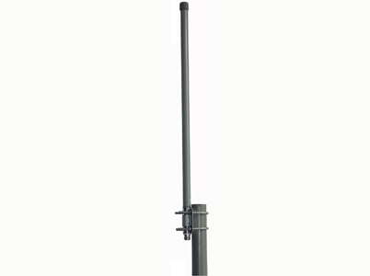
Orinoco Wireless Radio
Ethernet Cable
Ethernet Cable
NOTE
Mikrotik Port 1: Public
Mikrotik Port 2: WLAN
Hotspot
EBONYI STATE UNIVERSITY, ABAKALIKI ICT/RESEARCH CENTRE NETWORK DIAGRAM
DC Injector
Amplifier
Omni directional antenna
Ethernet Cable

