Consider the following simple network (very similar to example in talk, just with longer and more fiber links):
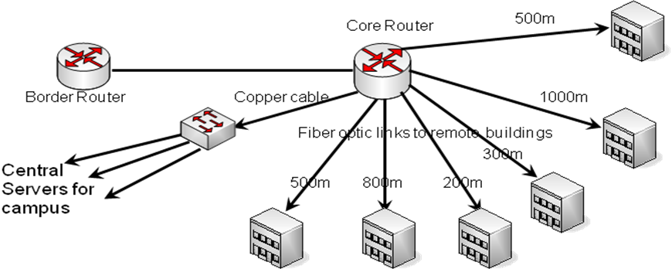
Use the tables below to develop pricing for a network based on gigabit Ethernet and 10gig Ethernet links for all fiber types (OM1, OM2, OM3, OM4, and G.652.D).
Types of Optical Interfaces
Standard | Speed |  | Supported Fiber |  |  |  | Cost
100baseFX | 100Mbs |  | MM |  |  |  | $250
1000baseSX | 1000Mbs |  | MM |  |  |  | $500
1000baseLX/LH | 1000Mbs |  | MM or SM |  |  |  | $1,000
10GbaseSR | 10Gbs |  | MM |  |  |  | $1,500
10GbaseLRM | 10Gbs |  | MM |  |  |  | $1,300
10GbaseLR | 10Gbs |  | SM |  |  |  | $4,000
10GbaseER | 10Gbs |  | SM |  |  |  | $10,000
Distances Supported by Interfaces
Standard |  | OM1 |  | OM2 | OM3 |  |  | OM4 |  | G.652.D
100baseFX |  | 2km |  | 2km | 2km |  |  | 2km |  | No
1000baseSX |  | 275m |  | 550m | 1km |  |  | 1.1km |  | No
1000baseLX/LH |  | 500m |  | 500m | 500m |  |  | 500m |  | 10km
10GbaseSR |  | 33m |  | 82m | 300m |  |  | 550m |  | No
10GbaseLRM |  | 220m |  | 220m | 220m |  |  | 220m |  | No
10GbaseLR |  | No |  | No | No |  |  | No |  | 10km
10GbaseER |  | No |  | No | No |  |  | No |  | 40km

Cost of Fiber
Fiber Type | Budget Cost per km
OM1 | $4,884
OM2 | $4,054
OM3 | $10,151
OM4 | $19,959
G.652.D | $1,185

Here are some worksheets to use.
What is the total installed fiber length?
Cost of 1 Gigabit Network
Fiber Type | Fiber Cost | Optics Used | Optics Cost | Total Cost
OM1
OM2
OM3
OM4
G.652.D

Cost of 10 Gigabit Network
Fiber Type | Fiber Cost | Optics Used | Optics Cost | Total Cost
OM1
OM2
OM3
OM4
G.652.D

