Building Your Own Telco: An Overview

Onno W. Purbo

Detail Handbook:
- https://nsrc.org/workshops/2011/wirelessu-interlab-nsrc/attachment/wiki/Agenda/VoIP-Cookbook-20100310.pdf
- http://opensource.telkomspeedy.com/speedyorari/index.php?dir=ebook-voip
- http://belajar.internetsehat.org/pustaka/library-onno-eng/practical-guide-rebelnet/the-guide/

The Big Idea
In simple words
- Build your own Telco at low cost.
- Build phone switch (softswitch) over the Internet.
- Able to use +66XXXXXXX (e.g. for Thai number)
- Able to call the old Phones.
- Optionally able to evolve to GSM Base Station (e.g. using OpenBTS)

The Big Picture
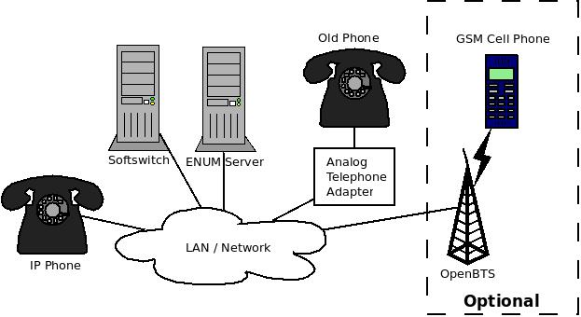
Simplified Internet Telephony infrastructure:
- Softswitch – maps VoIP number - device address (IP address).
- ENUM Server – maps VoIP number - Telco's number (e.g. +66XXXXXX for Thai).
- IP Phone, WiFi Phone, Softphone & Analog Phone are the clients.
- OpenBTS – for GSM Cellular (optional).

Configuration Principal

Minimal Softswitch Configuration
- Softswitch is basically a software that runs on server, e.g. asterisk (http://www.asterisk.org) and opensips (http://www.opensips.org).
- Setup Client Authentication (username & password) – in asterisk /etc/asterisk/sip.conf
- Setup Routing Table (Dialplan) – in asterisk /etc/asterisk/extensions.conf.

Minimal ENUM Server
- ENUM is basically DNS Software runs on server, e.g. BIND.
- Setup zone of ENUM – in BIND /etc/bind/named.conf.local
- Setup NAPTR data

Client
- Client can be software (softphone) or hardware (IP Phone, WifiPhone, ATA).
- Setup client to register to Softswitch. We need to supply username, password, softswitch hostname / ip address.

Cost
- Open source softswitch and ENUM are free.
- Open source softphone are free.
- IP phone, Wifi Phone, ATA are around US$50-150 each.

Build Your Own GSM Operator: Optional

We can expand our VoIP infrastructure to GSM / selular using USRP and OpenBTS. The normal GSM handphone with any SIM card will likely to work on OpenBTS. Interconnection is done via VoIP.

Additional Hardware
- Universal Software Radio Peripheral (USRP) from http://www.ettus.com

Software
- Softswitch, e.g. asterisk (http://www.asterisk.org)
- GNURadio http://gnuradio.org
- OpenBTS http://www.openbts.org

