Kabarak University – Wireless Campus Network

Table of Contents

Map 1
Site Survey 1
Uplink 1
Users 2
Overall wireless plan 2
Sectorization 3
Choice of hardware 3
Appendix: List of point-to-point links and hotspots 4

Version | 0.1
 | Sebastian, created

Introduction

The following is a collection of discussions and plans from our email based preparation of the Kabarak / NSRC / GASP workshop and deployment, June 2012.
It is work in progress.

Map

A google map of the campus and the relevant network locations is here:
http://maps.google.com/maps/ms?msa=0&msid=201438497641623639195.0004bfc2d419e4c36f134
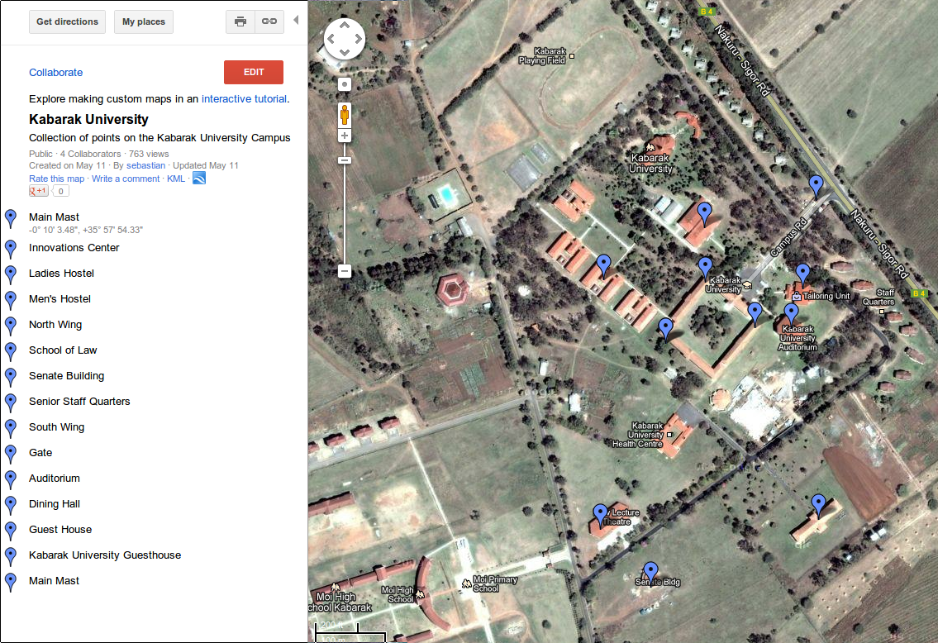Illustration 1: Campus overview map

Site Survey

A list of links, distances and obstacles is given in the Appendix.
(Here, we could add a report from a full site survey.
Specifically, it would be important to know about any other wireless activity on our near the campus.)

Uplink & bandwidth

”We currently have 12 Mbps bandwidth at the campus. We are looking to increasing this to at least 20 Mbps in 2013.”
Wireless bandwidth for internet access on campus should be designed to fit the available uplink bandwidth. It does not make sense to accumulate more internet traffic on campus than we can handle on our gateway / uplink.
A single access point can deliver
802.11b | 5 Mbps
802.11a/g | 20-25 Mbps
802.11n | 150 Mbps
This means that for the immediate future, 802.11b would supply more than enough bandwidth on campus. A total of 10-15 access points running 802.11b could produce 50 – 75 Mbps, when utilzed fully.
However, modern wireless equipment for end user access typically will allow for activation of 802.11n at a later stage.
Traffic internal to the campus would of course benefit from larger bandwidth. Therefore, point-to-point links should provide plenty of margin.

Users

”We have approximately 500 users with laptops at the moments on the entire campus and of course it is growing.
The total population at the campus is 1500 plus. Having a good wireless internet connection will encourage more students and staff to buy laptops. ”

The wireless network should be planned to accomodate 3000+ clients.

Overall wireless plan

The wireless component of the campus network serves two main purposes:

- Core Infrastructure: roll out connectivity from main mast / NOC to the various buildings and sites on campus
- Edge Access: Hotspots and coverage for users/clients

To the extent possible, the two purposes should be served separately, e.g. separated by choice of frequency/standard.

A possible approach for Kabarak University is:
- Backbone on 5 Ghz / 802.11a or TDMA
- User Access on 2.4 Ghz (802.11 b/g/n)

The network would thus consist of
- about 10-15 hotpots / access points at the various buildings
- backbone links connecting these buildings to the central mast and uplink

To the extent possible, backbone infrastructure should be wired (cable and/or fiber). Backbone wireless point-to-point links might be replaced by fiber.
The cost of fiber/cable needs to be compared with the cost of wireless links. With links typically being just a few hundred meters, cabling might well be cheaper or of the same price class as wireless.

Sectorization

The initial idea suggested one central access point to serve all of the campus.
Separating backbone from access network, we suggest to replace this approach with point to point links.
However, since there might not be a budget for building 15+ point to point links, a good compromise might be sectorization, i.e. Serving several remote locations from one radio/antenna, located on the main mast. The sketch makes a first suggestion, dividing the backbone network into four ”slices”, each about 30-90 degrees wide.

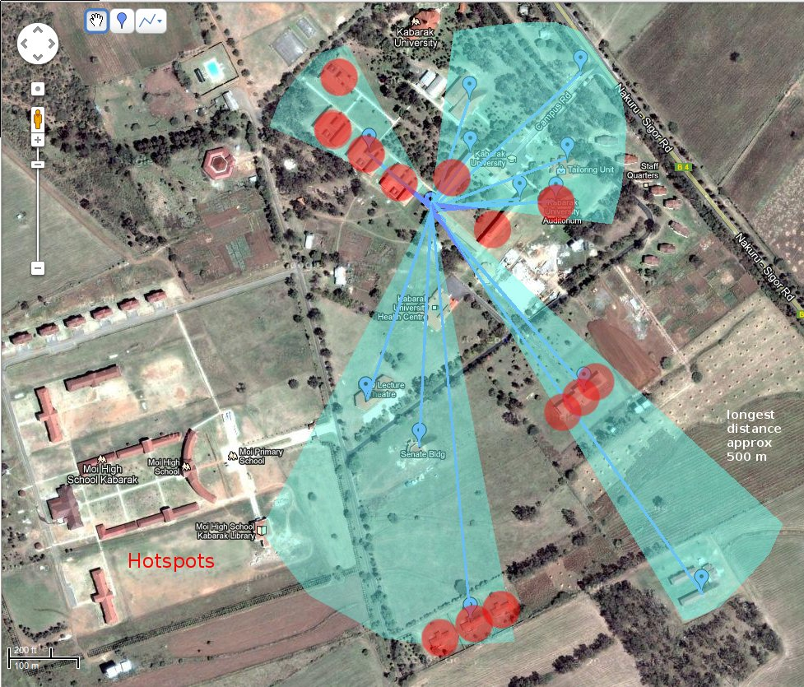Illustration 2: Wireless design - sketch

Choice of hardware

The initial plan suggested

- Wavion Wireless Base Station 2.4GHZ

http://wavionnetworks.com/innerData/pdf/Wavion%20WBS-2400%20Datasheet_NEW.pdf
- LevelOne WAB-6120
http://www.provantage.com/cp-technologies-wab-6120~7CPTC0PK.htm

Separation of backbone and access network might suggests a different choice: e.g.

- Ubiquiti Airmax for Backbone links (Nanostation/Loco M5, Nanobridge M5)
- Ubiquiti Unifi for user access
Other options should be discussed and prices compared.

Appendix: List of point-to-point links and hotspots

We have categorized areas to be covered by the wireless link into two groups.
- Point to point links
- Hotspots
POINT TO POINT (STAFF )
Locations | Name |  |  |  | Coordinates |  | Distances (appr) |  |  | Obstacles
Location 1 | Student Centre Staff |  |  |  | -0.166994,35.962361 |  | 400 |  |  | Trees
Location 2 | School of Law Staff |  |  |  | -0.169794,35.964421 |  | 200 |  |  | Build &Trees
Location 3 | Gate |  |  |  | -0.16576,35.967007 |  | 400 |  |  | Build &Trees
Location 4 | Senior Staff quarters |  |  |  | -0.172809,35.965601 |  | 400 |  |  | Build &Trees
Location 5 | Senate Building |  |  |  | -0.170706,35.964904 |  | 300 |  |  | Build &Trees
Location 6 | Mast |  |  |  | -0.167788,35.965279 |  | 0 |  |  | None
POINT TO POINT (STUDENTS )
Locations |  |  | Name |  | Coordinates |  | Distances (appr) |  |  | Obstacles
Location 1 |  |  | Guest House |  | -0.172198,35.96853 |  | 500 |  |  | Build &Trees
Location 2 |  |  | School law labs |  | -0.169644,35.964539 |  | 200 |  |  | Build &Trees
HOTSPOTS
Locations |  | Name |  |  |  | Coordinates |  | Distances (appr) | Obstacles  With mast
Location 1 |  | Men’s hostel point A |  |  |  | -0.167219,35.964891 |  | 100 | Build &Trees
Location 2 |  | Men’s hostel point B |  |  |  | -0.166672,35.964237 |  | 150 | Build &Trees
Location 3 |  | Men’s hostel point C |  |  |  | -0.166232,35.963808 |  | 200 | Build &Trees
Location 4 |  | Men’s hostel point D |  |  |  | -0.165578,35.963958 |  | 300 | Build &Trees
Location 5 |  | Ladies hostel point A |  |  |  | -0.169655,35.967316 |  | 250 | Build &Trees
Location 6 |  | Ladies hostel point B |  |  |  | -0.169923,35.96708 |  | 270 | Build &Trees
Location 7 |  | Ladies hostel point C |  |  |  | -0.170116,35.966812 |  | 290 | Build &Trees
Location 8 |  | Staff Quarters point A |  |  |  | -0.166629,35.9675 |  | 310 | Build &Trees
Location 9 |  | Staff Quarters Point B |  |  |  | -0.167359,35.968187 |  | 300 | Build &Trees
Location 10 |  | Staff Quarters Point C |  |  |  | -0.168206,35.967929 |  | 320 | Build &Trees
Location 11 |  | Auditorium |  |  |  | -0.167359,35.966706 |  | 200 | Build &Trees
Location 12 |  | University quadrangle A |  |  |  | -0.167724,35.965419 |  | 50 | Build
Location 13 |  | University quadrangle B |  |  |  | -0.167005,35.965869 |  | 100 | Build &Trees
Location 14 |  | University mess area |  |  |  | -0.166168,35.965655 |  | 150 | Build &Trees

Prepared By: Jairus Ounza 5th May 2012. NB: Coordinates based on Google maps,
Appr (Approximate distance in meters from the mast), Build (Buildings)
Mast height approximately 36 meters.
Width 14 Inches.

NB: The mast is triangle
Shaped from bottom to top

