Network Management & Monitoring
Request Tracker (RT) Installation and Configuration

Notes:
- Commands preceded with "$" imply that you should execute the command as a general user - not as root.
- Commands preceded with "#" imply that you should be working as the root user.
- Commands with more specific command lines (e.g. "RTR-GW>" or "mysql>") imply that you are executing commands on remote equipment, or within another program.
- If a command line ends with “\” this indicates that the command continues on the next line and you should treat this as a single line.

Exercises

Exercise 0

Log in to your virtual machine as the sysadm user.

Exercise 1

Install the necessary packages for RT You should have mysql-server already, but we do the install just in case. This won’t cause problems.

Copy the “sudo apt-get install” lines below including the “\” character, minus the “$” and paste this in to your terminal session on your virtual machine.

$ sudo apt-get install rt4-apache2 rt4-clients rt4-db-mysql request-tracker4 libapache2-mod-fastcgi libfcgi-perl mutt

Respond “Yes” when prompted if you wish to install the packages.

You will now be presented with several windows. Read the follwing instructions to see how to respond:

Name for this Request Tracker (RT) instance:

Remove what is shown and replace with “netmgmt”, then select “<Ok>” and press
ENTER to continue.

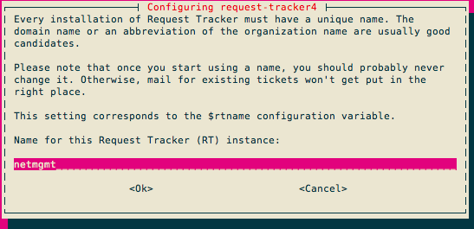

Handle RT_SiteConfig.pm permissions?

Select “<Yes>” and press ENTER to continue.

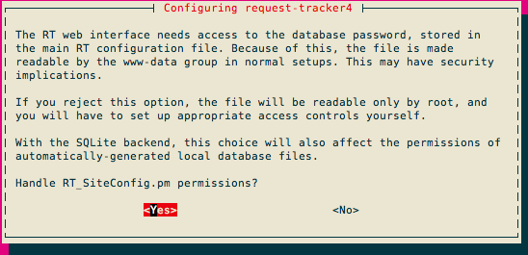
Configure database for request-tracker4 with dbconfig-common?

Select “<Yes>” and press ENTER to continue.

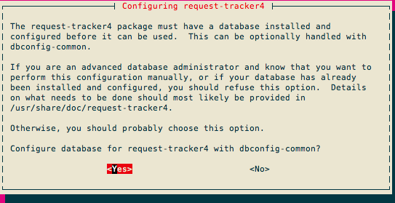

Password of the database's administrative user:

Enter the MySQL “root” or admin password. This was set earlier in the workshop
(probably when you installed Cacti). If you do not remember what this is, or if it’s
not written at the front of the classroom, ask an instructor for help.

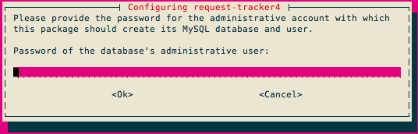

MySQL application password for request-tracker4:
You may enter any password you wish. This will be used by Request Tracker to
connect to MySQL. You generally do not need to remember this password. Pick
something that cannot be guessed easily (i.e., don’t use “rt”, “requesttracker”,
“1234”, etc…).

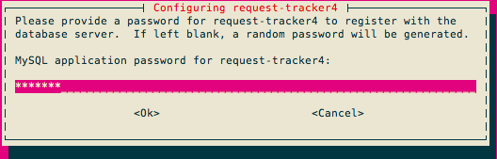

Password confirmation:

Enter the same password that you created in the previous step.

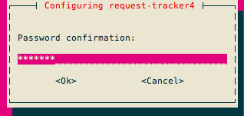

Initial root password for RT system:

Use the same password as we used for the MySQL database administrative user.

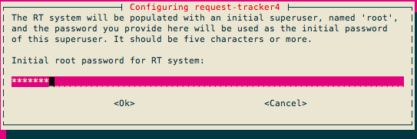

Now you will see quite a bit of information go across your screen as the Request Tracker installation process completes – It’s a big package.

At this point you have installed Request Tracker version 4. In order to access RT via the Apache web server you need to make a few small changes.

$ cd /etc/apache2/conf.d
$ sudo ln -s /etc/request-tracker4/apache2-fastcgi.conf .
$ sudo a2enmod fastcgi
$ sudo service apache2 reload

The last step could take up to 30 seconds, so be patient!
RT should now be up and running!

Exercise 2

Log in to RT as the root User

If you go to http://pcN.ws.nsrc.org/rt/ you will see the RT login screen:
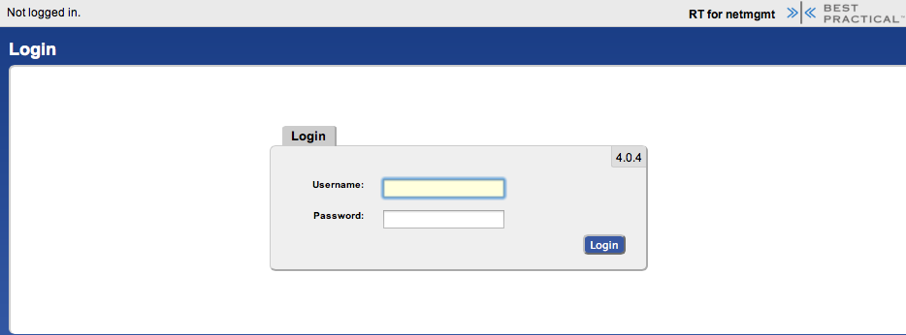
Enter the following information to log in as “root” on RT:
Username: root
Password: <SELECTED AT INSTALL>

Exercise 3

RT Configuration: Create a User

Now that you are logged in we will create a new user for the rest of these exercises.

On the top of the screen choose Tools ➔Configuration ➔ Users and then click on the Create item in the menu.
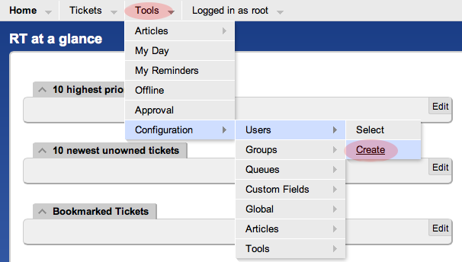

You will now be presented with the following dialogue. Fill in the fields, and make sure the checkbox "Let this user be granted rights" is checked. Set your email to sysadm@pcX.ws.nsrc.org (X = your PC)

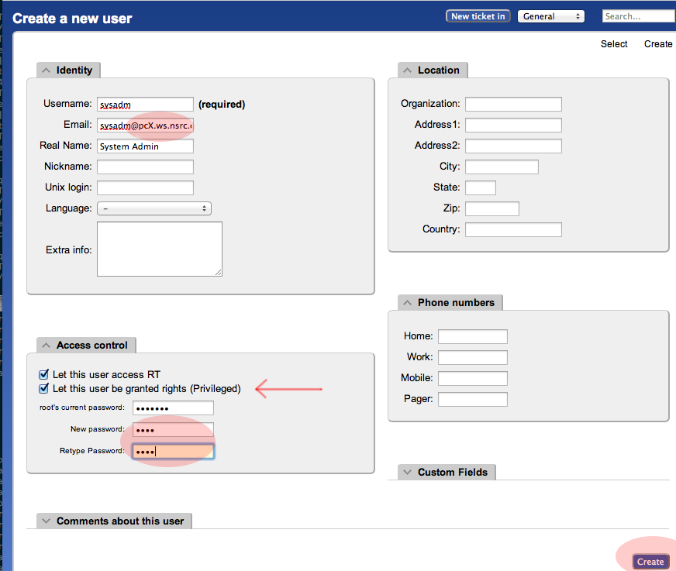

Use the same password for “sysadm” as you are using in class. Be sure you check “Let this user be granted rights”. Once done, scroll down the page and click on the Create button (bottom right).
You should see this:

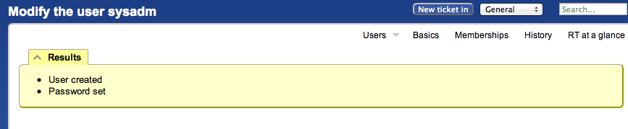
Exercise 4

RT Configuration: Create a Group

- At the top, choose the menu Tools ➔Configuration ➔Group ➔Create

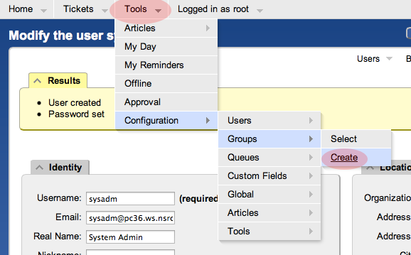

- Fill in the name: "netmgmt", and add a description, then click on "Create"

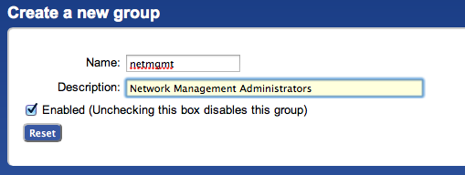

- You should see the following result (next page):
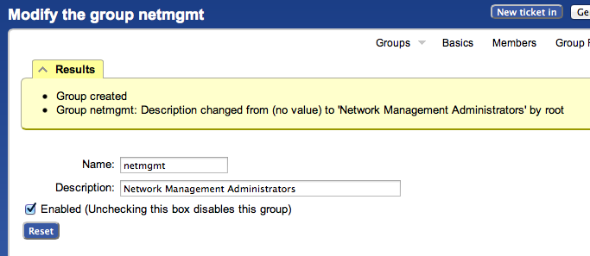

- Click on Members (top menu)

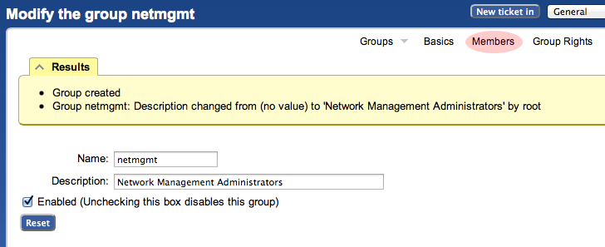

- In the "Add members" field (right), type in the name of the user you created in step 3. This is the “sysadm” user. Then click on Modify Members (bottom right):

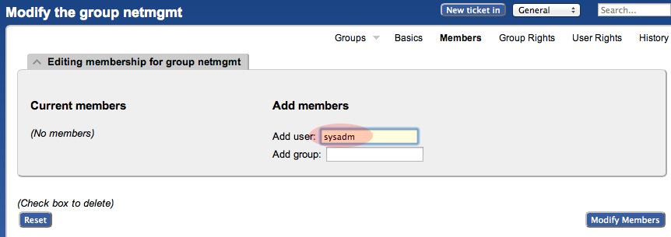

- You should see this:
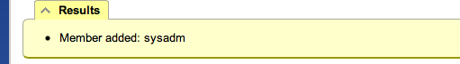

Exercise 5

RT Configuration: Create a New Queue

- At the top, choose the menu Tools ➔Configuration ➔Queue ➔Create

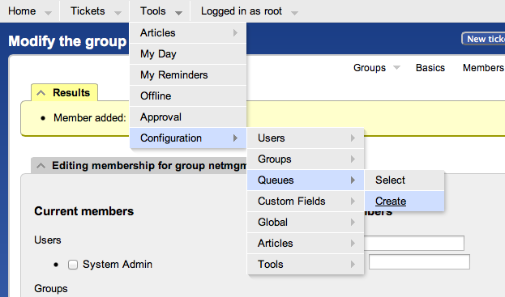

- Fill in the fields. Let’s use the following values and then click on Create:
Queue Name: net
Description: Network Problems
Subject Tag: Request Tracker: NET
Reply Address: net@pcX.ws.nsrc.org
Comment Address: net-comment@pcX.ws.nsrc.org
- Remember to replace pcX with the correct number of your machine

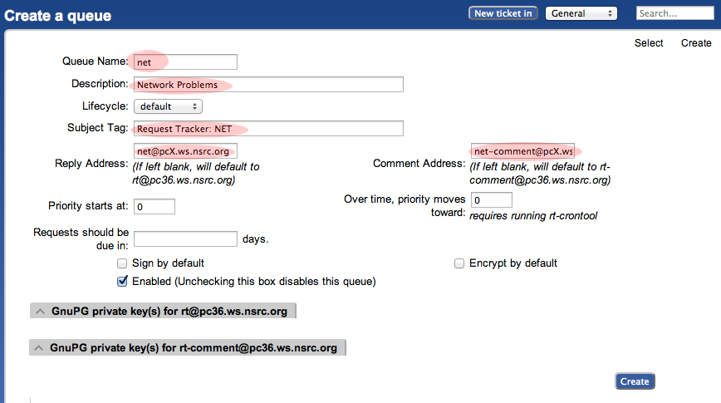

- You should see this
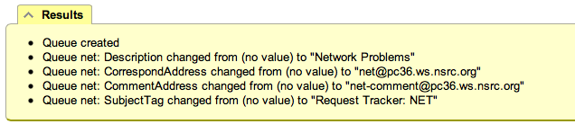
Exercise 6

RT Configuration: Give Rights to our Group on the Queue

- From the top menu, select Tools ➔Configuration ➔Queue ➔Select
- You should see:

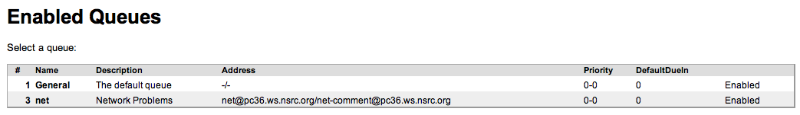

- Select “net” (click on it) then choose “Group Rights” (top right)

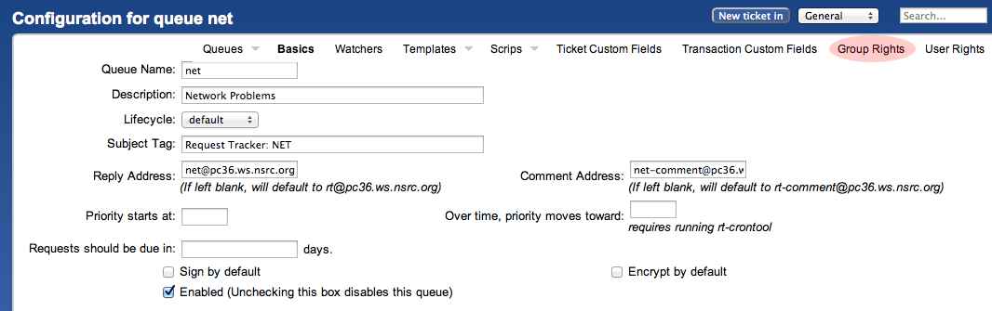

The following page should look like this:

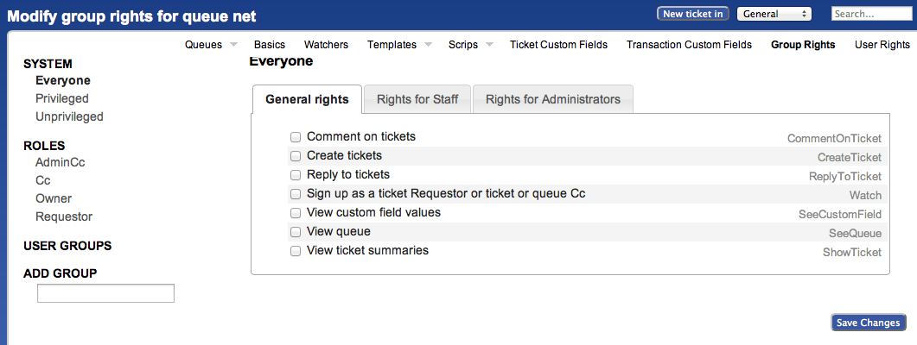

Note the three categories: “General rights”, “Rights for Staff”, “Rights for Administrators”

Here, we care about giving Everyone (including people who are not yet known to RT) some privileges, but only the minimum. These are General Rights, and are the following:

- ☑ Create tickets (CreateTicket)
- ☑ Reply to tickets (ReplyToTicket)
- ☑ View queue (SeeQueue)
- ☑ View ticket summaries (ShowTicket)

So start by selecting these 4 privileges by checking the 4 boxes in your browser.

Notice that Everyone on the left is already highlighted.

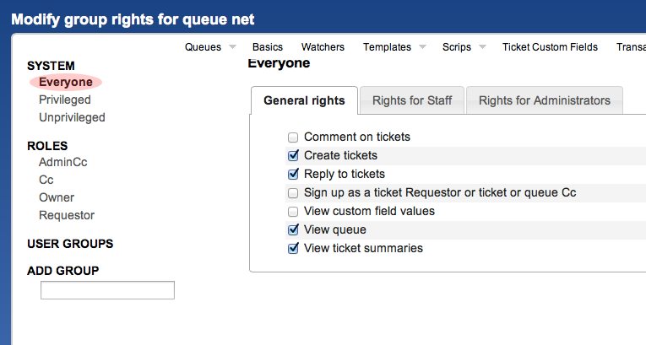

Now, click Save Changes (bottom right) to make sure we don’t lose our changes.

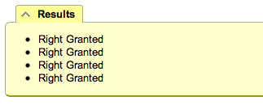

Staying on the same page, we’re going to now give the netmgmt Group everything…

To do this, first type in the name of the group in the ADD GROUP field in the lower left:

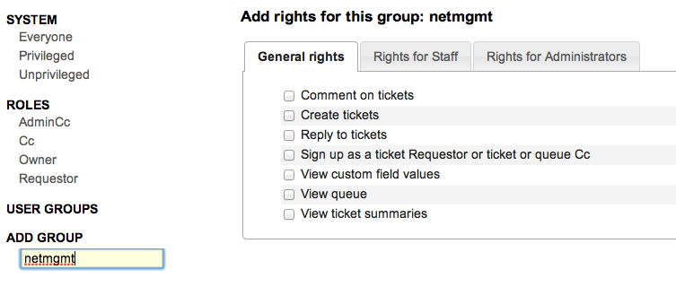

Now check ALL the boxes in “General Rights”, “Rights for Staff”, “Rights for Administrators”.

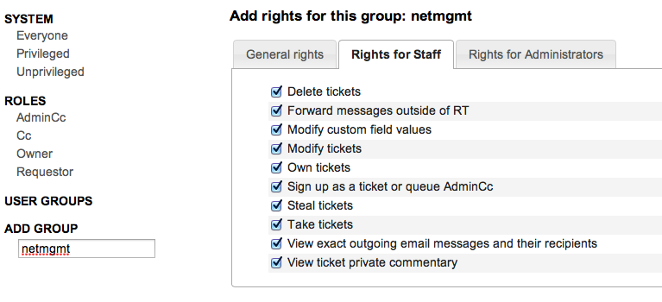
Once this is done, press the Save Changes button on the bottom right of the page. You should see:

This is after having selected items. Remember to press Modify Group Rights after selecting the new rights. Once you press the “Modify Group Rights” button you will see a bunch of this:

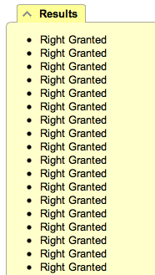

Exercise 7

RT Configuration: Log in as sysadm

Log out of RT (top menu, Logged in as root ➔Logout)



Now log back in as the sysadm user you have created:

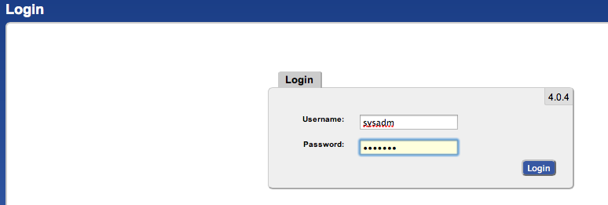

You should see the following:

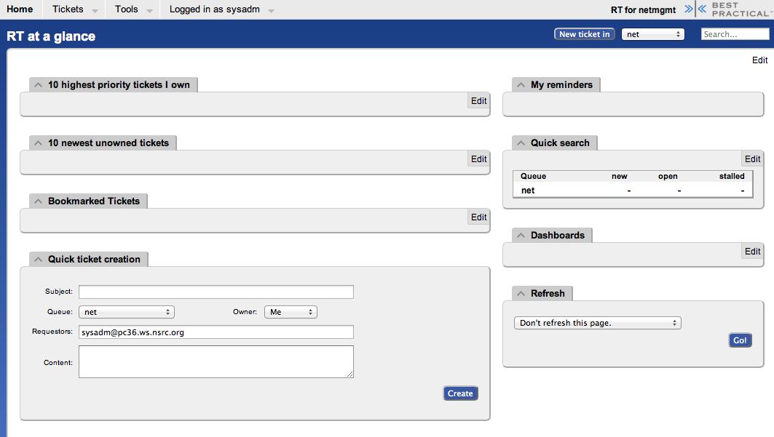

At this point RT has been properly configured for initial operation. Now we must configure email properly to talk with our new “net” queue in RT.

Exercise 8

RT Configuration: Email

RT will work with the MTA (Mail Transfer Agent) of your choice. In our case we are using Postfix configured to run as an MTA for an “Internet Site” – that is, to deliver email locally and remotely using SMTP.

Edit the file /etc/aliases

$ sudo editor /etc/aliases

Add the following two lines at the end of the file (copy and paste!):

net-comment: "|/usr/bin/rt-mailgate --queue net --action comment --url http://localhost/rt/"
net: "|/usr/bin/rt-mailgate --queue net --action correspond --url http://localhost/rt/"

Save the file and exit. Some editors might cause the above-lines to become multiple lines. Be sure that you only have two new lines in your /etc/aliases file after copying and pasting in the text above.

Now run the command:

$ sudo newaliases

Exercise 9

RT Configuration: Create an Email and Tickets

Let’s create an email and send it to the RT “net” queue. Do this as the sysadm user (not as root!):

If root:
# su - sysadm

$ echo "Problem with my router" | mail -s "Router problem" \ net@pcX.ws.nsrc.org

Remember to replace pcX with the correct name of your server.

Now check that you have received email:

$ mutt

You should see an email from Request Tracker acknowledging that your ticket has been created.

The mail should say something similar to this:
_______________________________________________________________________
Date: Fri, 9 Nov 2012 00:29:27 +0000
From: Network Problems via RT <net@pcX.ws.nsrc.org>
To: sysadm@pcX.ws.nsrc.org
Subject: [Request Tracker: NET #1] AutoReply: Router problem

Greetings,

This message has been automatically generated in response to the
creation of a trouble ticket regarding:
"Router problem",
a summary of which appears below.

There is no need to reply to this message right now. Your ticket has been
assigned an ID of [Request Tracker: NET #1].

Please include the string:

[Request Tracker: NET #1]

in the subject line of all future correspondence about this issue. To do so,
you may reply to this message.
Thank you,
net@pcX.ws.nsrc.org
_______________________________________________________________________

If, for some reason, you do not see mail try taking these steps, and then send the mail again:

$ sudo touch /var/mail/sysadm
$ sudo chown sysadm:mail /var/mail/sysadm

Exercise 10

RT Configuration: View, Reply, Resolve, Reopen Tickets in Request Tracker

Go back to your web browser where you are logged in to RT as the sysadm user and click on the Home menu item (top left).

You should then be presented with an updated view with the current ticket:

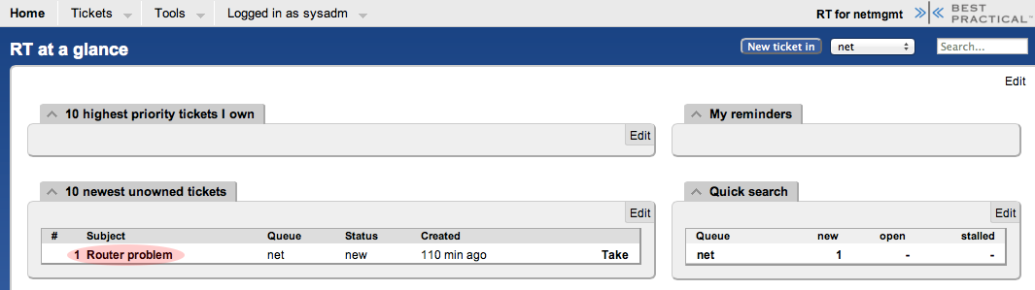

Now, click on the ticket subject.

You will see many pieces of information about the ticket. Scroll to the bottom of the page.

Here you can Reply to the ticket:

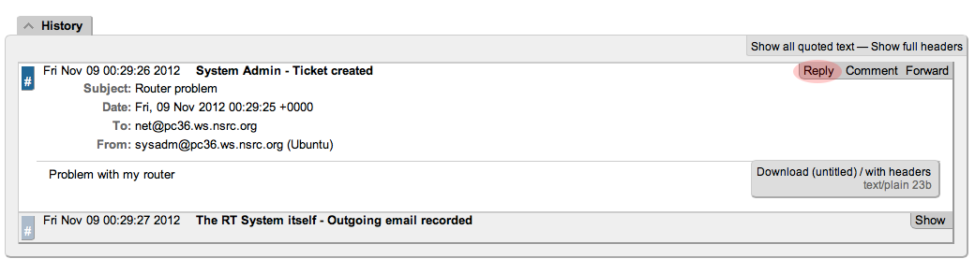

Go ahead and type in a reply, set the Status of the ticket to Resolved (upper-right drop-down menu), and then click on Update Ticket (bottom-right):

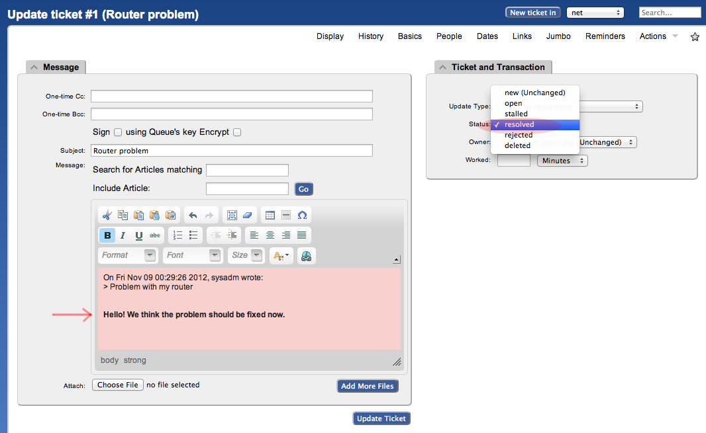

You should see this:

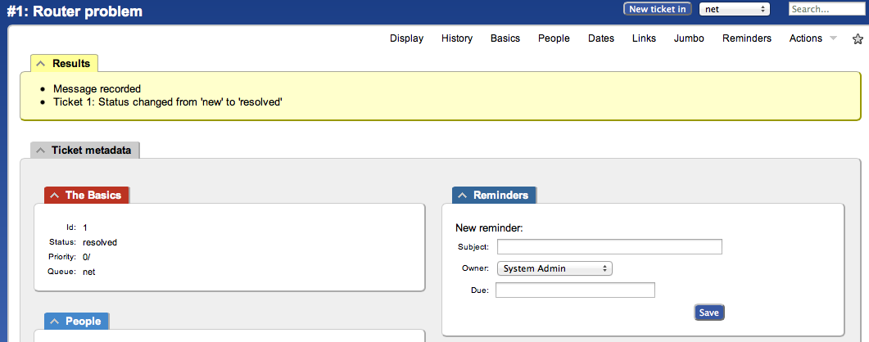
The ticket is currently “Resolved,” but you can either reopen the ticket via the RT web interface at any time, or if the original ticket creator (sysadm in this case) replies to the email you just sent, then the ticket will be reopened.

View the history at the bottom of the page to see that the ticket is currently closed:
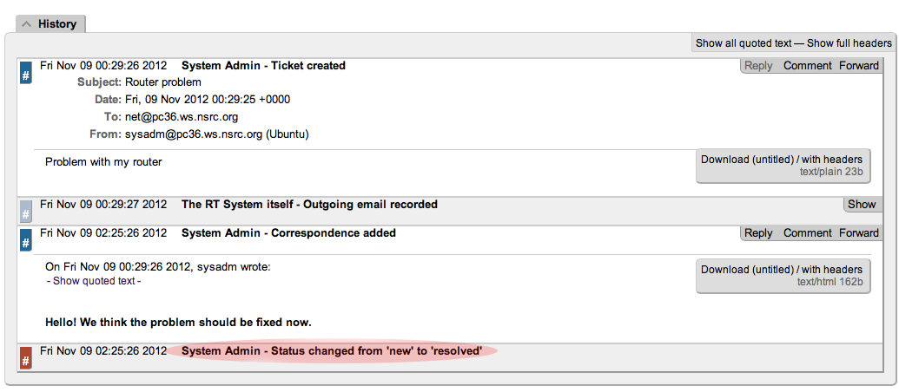

If you went back to your terminal session as the sysadm user and typed:

$ mutt

and responded to the email generated from Request Tracker, then your ticket status will change. You can see this by reloading the RT web page for the ticket and viewing the history at the bottom of the page:

Using Mutt to Reply to an Email

- After typing “mutt”, select the message you want to respond to.
- Press the “r” key for “r”eply.
- At the bottom of the page you will see, “To: System Admin via RT <net@localhost>” –
Press ENTER to continue.
- Next you’ll see a suggested “Subject:” line. Press ENTER to choose what is shown.
- When you see, “Include message in reply? ([yes]/no):” press ENTER to include the message.
- Now you will be placed in an editor – possibly vi. Type in your response. We suggest at the bottom of the page.
- Save and exit from the text editor (:wq in vi).
- The next time screen looks complicated but in reality just press the “y” key to send the message.
- That’s it. You are done. You can press “q” to exit Mutt at this point if you wish.

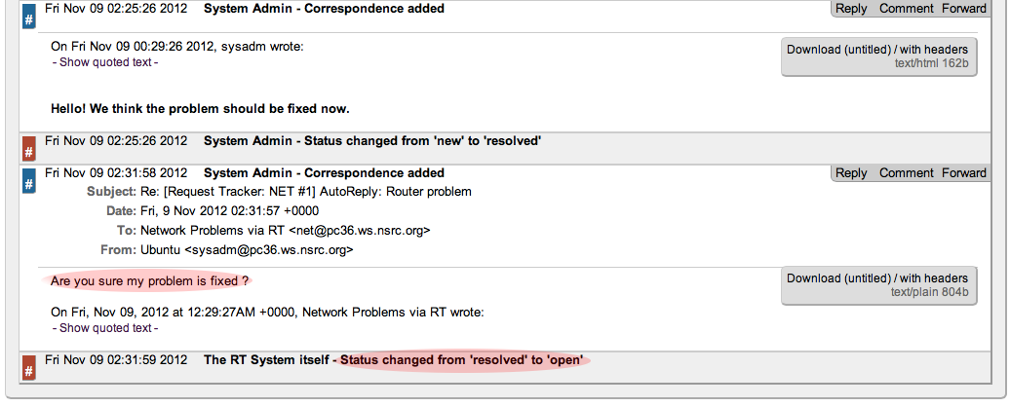

You now have a functioning RT instance with email integration!

You can experiment a bit. Now, this is not a very realistic setup, since you are communication with yourself! But in fact, other users in the classroom can send you email:

- Make sure they have configured their mail software (sudo apt-get install postfix then accept the defaults)
- Have the users send a mail to you, for example:
echo "Where is my cat ?" | mail -s "Missing cat" net@pcX.ws.nsrc.org

- This should automatically create tickets in the net queue on your pc “pcX” – verify that you do receive the tickets!

But we’re still missing an important feature: it’s not practical to have to log into RT to check if tickets have arrived. It would be much more convenient if we received an email that a problem request had been submitted, no ?

To do this, we’re going to modify the Queue settings for net:

- From the top menu, select Tools ➔Configuration ➔Queue ➔Select

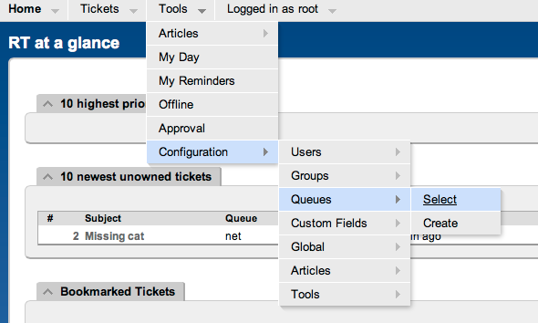

From the Queue page, select the net queue by clicking on its name, and you select the Watchers menu option at the top:

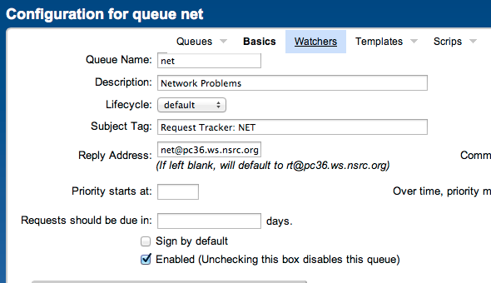

You should now see this:
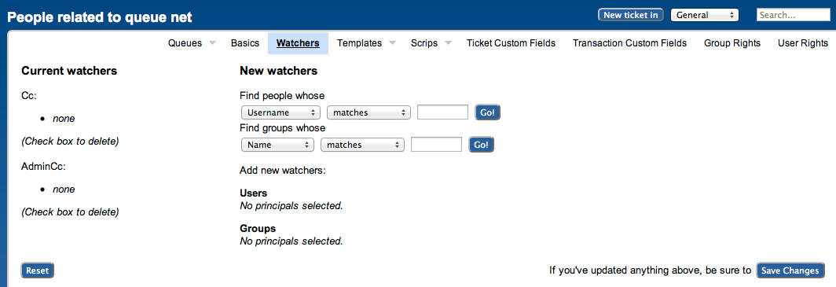
Under New watchers, enter the group name netmgmt in the field:
“Find groups whose [NAME] [matches]”, as such:

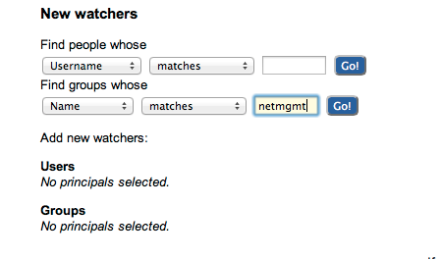
And click on Go!

RT will search for all groups matching netmgmt. Of course there is only one right now, which we created earlier. RT finds it and displays the following:

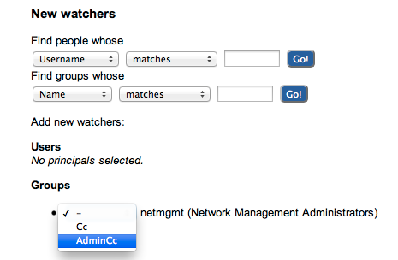

Notice how we select “AdminCc” from the pull down memu Groups next to netmgmt. Do this and click on Save Changes at the bottom right.

The result should look like this:
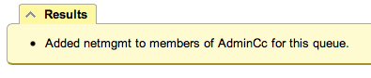
What does it mean ? Well, ask another user to send you a mail, like before, but this time you should receive a mail from RT with the ticket notification – check mutt as sysadm.

A bit later we will extend the use of RT by integrating it with other Network Monitoring software using the rt-mailgate facility that we have already configured in the /etc/aliases file.

Exercise 11

Finding a ticket once it’s closed.

After a ticket has been resolved or closed may notice that it disappears from your Queue. Actually finding a closed ticket requires a few steps. First, click on Tickets ➔ New Search on the top menu in RT:
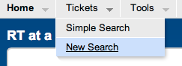
and you will see a screen like this:

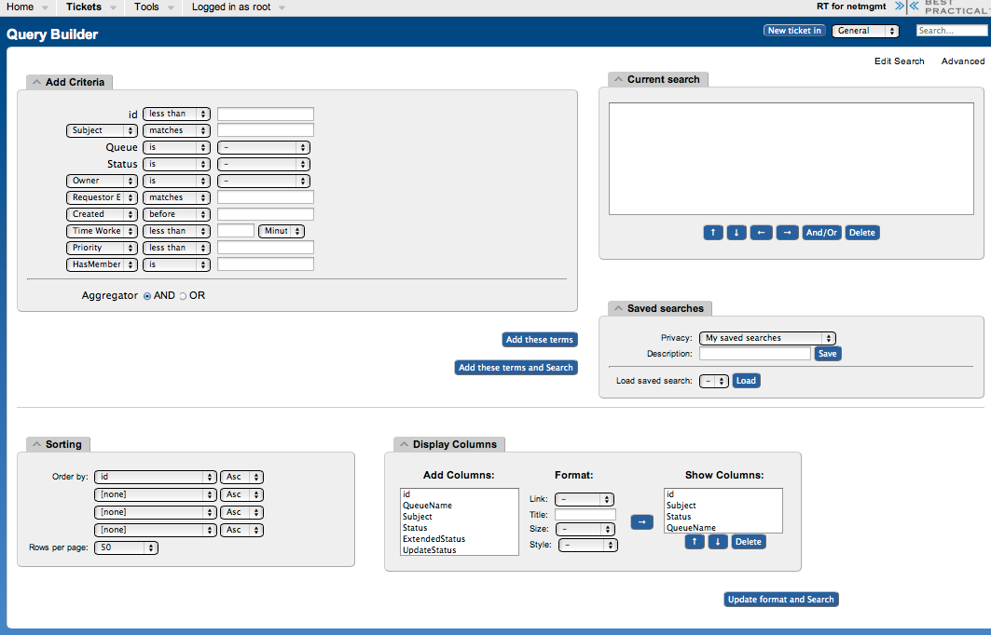

If you are going to search for items in a queue and there are already items in the “Current search” box, then you should delete the items from the “Current search” box first. Next in the “Add Criteria” box in the “Queue” choice select the “net” queue from the drop-down menu (see below):

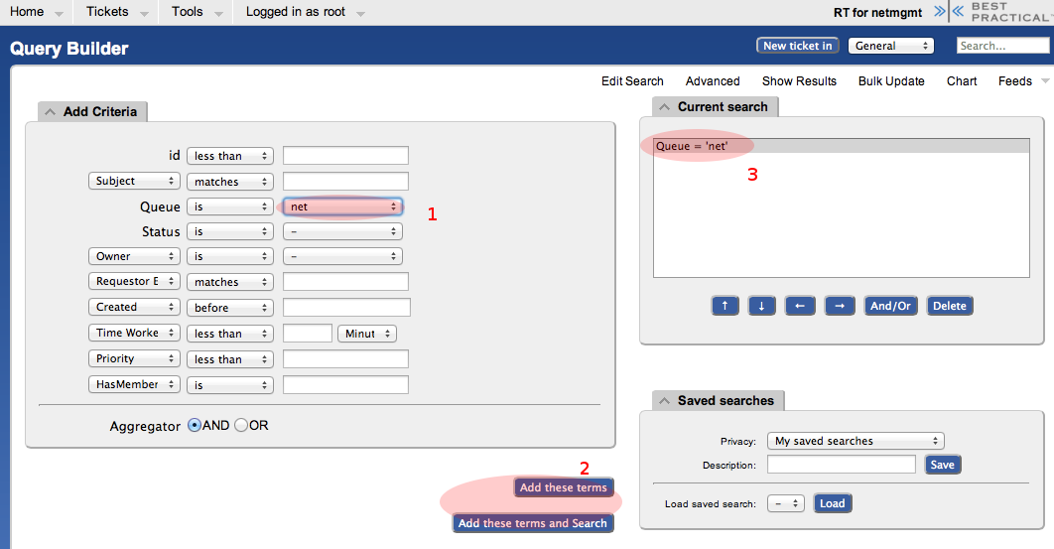

Click on “Add these terms” or “Add these terms and Search” – If you just do “Add these terms” then go to the bottom of the page and click on “Update format and Search” – RT will keep the search terms until you delete them at a later time.

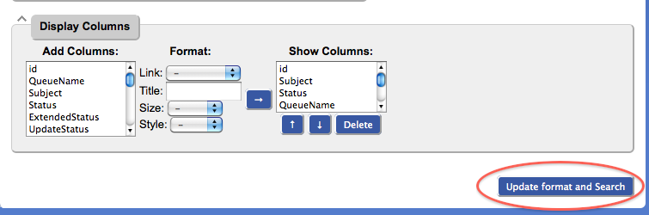

And the results of your search will look something like this and you will be able to view tickets that have been closed, resolved, etc. Clearly there will be more tickets in the results over time:

