**Using GIMP for scanning and creating Tiffs** (8/2012)

1. Turn on scanner before you open applications.
2. Open Gimp (GNU Image Manipulation Program)
3. Go to File🡪 Create🡪 Scanner/Camera…
4. A dialog box will appear asking you to choose your source (choose Epson Expression 10000).

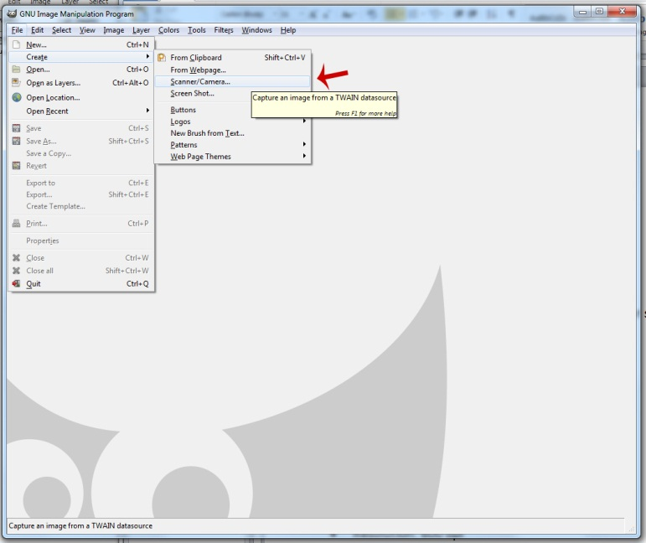

1. ***Scan according to the Epson Scan Flatbed Scanning instructions***.
2. After your image has been scanned and appears in GIMP, you may need to rotate it accordingly. (To rotate: Click on Image🡪 Transform🡪 then choose how you want to rotate)
3. **Saving tiff files in GIMP**. Go to the *File* menu and click on *Export*.

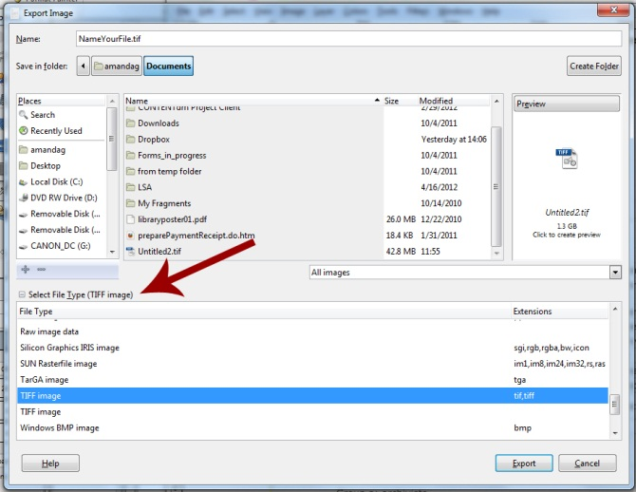

1. Now, in the export window, name your file according to your naming conventions, and click on *Select File Type* and select *TIFF image* from the list.
2. While GIMP doesn't offer quite the same degree of flexibility in saving TIFFs as Adobe Photoshop (which can save layers in TIFFs), it does offer several compression options, however, for most people, the attraction of TIFFs is that they maintain maximum image quality without compression. So choose None.

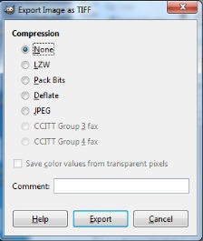

1. If you want to save an image from GIMP that you can later work on many more times, TIFFs are ideal as you won't be losing any image information each time you save your image if you choose not to use compression.